**St Columba’s Church, Selsdon**

37 Queenhill Road, Selsdon, South Croydon, CR2 8DW

Parish telephone number: 020 8657 3747

Parish Priest: Father Roy Tablizo

E: [selsdon@rcaos.org.uk](mailto:selsdon@rcaos.org.uk)

Deacon: Rev. Philip Pond E: [philippond@rcaos.org.uk](mailto:philippond@rcaos.org.uk)

T: 020 8651 4653

Parish website: [www.stcolumbaschurchselsdon.uk](http://www.stcolumbaschurchselsdon.uk)

**16th MAY 2021**

**7th SUNDAY OF EASTER (YEAR B)**

**THIS SUNDAY’S MASS READINGS**

**Entrance Antiphon:** O Lord, hear my voice, for I have called to you; of you my heart has spoken: Seek his face; hide not your face from me, alleluia.

**A reading from the Acts of the Apostles: 1:15-17. 20-26**

**Responsorial Psalm PS 102:1-2. 11-12. 19-20. Rv.19:** The Lord has set his sway in heaven.

**2nd Reading: A reading from the first letter of St John: 4:11-16**

**Gospel Acclamation:** Alleluia, Alleluia! I will not leave your orphans, says the Lord; I will come back to you, and your hearts will be full of joy. Alleluia!

**Gospel: John 17:11-19**

**Communion Antiphon:** Father, I pray that they may be one as we also are one, alleluia.

**ADORATION AGAIN EVERY TUESDAY MORNING**

On Tuesday mornings there is exposition and adoration of the Blessed Sacrament every week after 10am Mass.

It lasts for one hour from 10.30 – 11.30am every Tuesday. All are welcome. There is no congregational singing, note,

because of Covid.

**DON’T FORGET SATURDAY’S NOVENA TO OUR LADY…**

Come along to St Columba’s on Saturday morning at 10am and you can join in the novena to Our Lady.

Again, all are welcome. The short service will last no more than 20 minutes.

*The message is clear: we have a duty to reach out to other Christians*

A reflection on Sunday’s gospel by Deacon Philip

This, apparently, is a true story…

One Sunday, three Irish Protestant women decided out of curiosity to go to Mass in their local Catholic church.

Being so small, it was always very crowded, with standing room only for latecomers.

Spotting them during Mass and wanting them to feel welcome, the priest whispered to his altar server: ‘Three chairs for the Protestant ladies.’

The altar server immediately jumped to his feet and shouted ‘Three cheers for the Protestant ladies.’

At which the congregation duly stood up, responded heartily and the Mass continued.

A serious question now: how do we respond to members of other Christian churches in Selsdon, whether Anglican, Baptist, Methodist or Croydon Jubilee?

Do we view them suspiciously as other, different, not like us, somehow inferior?

Do we tend to think, on church matters, that we are always right and they are always wrong?

Do we avoid getting involved with them?

If your answer to any of those questions is ‘yes’, then you need to take a long, hard look at Sunday’s gospel.

Because its clear message is that we have a duty, a responsibility, to reach out to other Christians.

We are called, each and every one of us, actively to engage with them.

Who says so? Jesus himself.

I quote: ‘Holy Father, keep those you have given me true to your name so that they may be one like us.’

Note that phrase: ‘one like us’.

Not only are these Jesus’s own words.

Just as important are the circumstances in which he spoke them.

That was the night when the awful prospect of his imminent crucifixion might have been expected to obliterate everything else.

And yet one of the things that concerned him most at that troubled time was our unity as Christians.

To emphasise its importance, Jesus repeats the point:

‘Holy Father, I pray not only for these (his disciples) but also for those who…come to believe in me.

‘May they all be one…so that the world may believe it was you who sent me.’

Bear in mind too the context of his words. Significantly, they came during the Last Supper. They followed upon the institution of the Eucharist itself, the sign and source of the unity for which he prayed.

And which we are meant to practise.

That sharing in the one bread and the one cup was itself a celebration of unity and a powerful statement as to its importance.

So unity obviously meant an awful lot to Our Lord. And yet look at what followed over the past 2,000 years…

Jesus’s words fell on deaf ears.

Two millenia on there has been a fragmenting of the Christian community. We have not one Church but several separate Churches.

So what can we as individuals here at St Columba’s do to help make Christ’s prayer come true?

The first thing is to purge ourselves of prejudice. Stop thinking of ‘them’ and ‘us’.

Stop generalizing about ‘them’.

Stop thinking that we are always ‘right’ and they are always ‘wrong’.

Instead, let’s get to know local Anglicans, Baptists, Methodists, Jubilarians better.

In future, let’s treat everyone we meet of another denomination (or none at all) with openness, tolerance and respect.

And if by any chance we see some here with us at Mass one Sunday, why not stand up – and give them three cheers.

|  |  |
| --- | --- |
| **LITURGICAL CALENDAR OF THE WEEK** | |
| Sat 15th | Weekday of Easter |
| Sun 16th | 7th Sunday of Easter |
| Mon 17th | Weekday of Easter |
| Tues 18th | Weekday of Easter or Saint John I, Pope, Martyr |
| Wed 19th | Weekday of Easter or Saint Dunstan, Bishop |
| Thurs 20th | Weekday of Easter or Saint Bernardine of Siena, Priest, Religious, missionary |
| Fri 21st | Weekday of Easter or Ss Christopher Magallanes, Priest, and companions, Martyrs |
| Sat 22nd | Weekday of Easter or Saint Rita of Cascia, Religious |
| Sun 23rd | Pentecost Sunday |

**REMEMBER THE SICK AND NEEDY**

Please pray for all those in need at this time including: Douglas & Yvonne Bruce, Stephen Beck, Colin Furk, Vera De Souza, Mike Bond, Alice Barclay, Thelma Benn, Julie Ballesteros, Cora Litchfield, Sean Walsh, Judy Freegard, Imogen Fernando, Joan Cunningham, Solveya La Marina, Chris Jones, Maria Reece, Margaret Bolton, Eddie Aldridge, Ellis Warburton, Mary Marks, Jean-Claude Anthony, Ellen Everett, Maureen Coffey, James Guckian, Elizabeth Sensano and sick residents at the four residential homes usually, in better times, visited by the parish St Vincent de Paul group.

|  |  |  |
| --- | --- | --- |
| **MASS INTENTIONS FOR THE WEEK** | | |
| Sat 15th | 6.30pm | Gerry D’Souza, RIP |
| Sun 16th | 8.00am | Pro Populo |
| Sun 16th | 10.00am | Jesus Melenab, RIP |
| Sun 16th | 6.30am | Jackie Iles, RIP |
| Mon 17th | 10.00am | Geoff Turner, RIP |
| Tues 18th | 10.00am | Kathleen O’Halleron, RIP |
| Wed 19th | 10.00am | Cathy Matias |
| Thurs 20th | 10.00am  7.30pm | Intention of the Alvarez family |
| Fri 21st | 10.00am | Michael Jones, RIP |
| Sat 22nd | 6.30pm | Pro populo |
| Sun 23rd | 8.00am | Jessica Harvey, RIP |
| Sun 23rd | 10.00am | Helga & Theo Schroder, RIP |
| Sun 23rd | 6.30pm | Private Intention (Coulsdon Catenians) |

**WORLD COMMUNICATION DAY**

Please pray for all communicators this Sunday (May 16) which is designated by the Church as World Communication Day.

To see Pope Francis’s message for this event click on:

<https://www.cbcew.org.uk/world-comms-2021-message/>

***PRECAUTIONS TO AVOID CATCHING COVID IN CHURCH***

We know we must take precautions when coming to Mass. They are set by the Government – and the local council is checking that we comply.

So every time you come to church make sure to:

* Remember to bring and wear a face mask covering the nose as well as the mouth. There are some available in church if you forget.
* Enter the church via the side door leading into the Sacred Heart chapel/confessional, observe the one-way system and leave via the centre back door.
* Meet Track-and-Trace requirements by providing a written note every time you come to church of your name and contact details plus the date and, if relevant, Mass time. To save queuing and filling out a form, send an email to selsdon@rcaos.org.uk
* Use hand sanitizer, provided, both when entering and leaving the church.
* Take a paper marker (during the week, not at the weekend) and leave it on your seat so that the stewards know where to clean.
* Leave where they are the chairs which have replaced some of our benches and are at 1m intervals to ensure the necessary social distancing.
* Bring your own Mass or prayer book – there are no shared items.
* Keep silent when receiving Holy Communion.
* Leave the church straight after Holy Communion and don’t congregate outside to socialise.

**WANT TO GO TO CONFESSION?**

Well you can – and at the same time be confident that you are safe from Covid. Simply give Fr Roy a ring and make an appointment. He will hear your confession in private in the hall.

***IF YOU TEST POSITIVE FOR COVID…***

Should that happen and you have been to Mass at St Columba’s in the preceding week, let Fr Roy or Deacon Philip know. For track’n’trace purposes, they may then need to contact anyone else who was at the same Mass. That’s when the track’n’trace forms which everyone attending Mass has to complete (unless they send an email) come into play

**FIRST COMMUNION & CONFIRMATION**

FIRST COMMUNIONS All parents (and the children) need to attend a meeting immediately following 10am Mass on Sunday (May 16). First Communions will take place on Sunday June 27 at noon.

CONFIRMATIONS Young people (age 13-14) wishing to receive the Sacrament of Confirmation are advised to write a short letter to Fr Roy asking to be confirmed.

**LIFE IN THE SPIRIT**

A series of Life in the Spirit seminars is being organised for personal and diocesan renewal over coming weeks.

Each attendee will be invited to grow in their love of the Lord, welcome the Spirit into their lives afresh and pray for the renewal of our diocese.

Taking place on Tuesday evenings from 8-9.30pm, the seminars will feature a talk from a gifted speaker and small group sharing.

Details are as follows.

May 18, speaker: Teresa Carvalho

May 25, speaker: Archbishop John Wilson  
June 1, speaker: Kathryn Murrell

To book for the seminars please click on this link:   
[Book here](https://rcsouthwark.us11.list-manage.com/track/click?u=a40ab1a35eac7236d856fe882&id=89b6876049&e=087693309e)

**On Saturday May 22 there will be a Pentecost retreat lasting from** 2-5pm, with Fr Pat Collins CM; a Vincentian priest based in Ireland.

Fr Pat is a founder member of the New Springtime Community, in addition to being a well-known international speaker, writer and broadcaster. [Register here](https://rcsouthwark.us11.list-manage.com/track/click?u=a40ab1a35eac7236d856fe882&id=270fe9e793&e=087693309e):



***SHOP ONLINE AND HELP ST C’S TOO***

Thinking of buying something online? Anything? A new washing machine or any other white goods?

Or perhaps you need a new vacuum cleaner or intend ordering a book or dvd or other items.

If you do it online you can help St Columba’s finances, depleted by the lockdown, at the same time and at no cost to yourself.

More and more parishioners are signing up for this scheme. It means that you can turn your everyday online shopping into free donations to our parish.

It’s simple. It’s straightforward. And it will cost you nothing.

All you have to do is to logon to the following website [www.easyfundraising.org.uk](http://www.easyfundraising.org.uk), register (which is quick and easy) and then go shopping online at whichever retailer you choose. Then, in future, every time you buy something – anything – a small donation is made to St Columba’s.

|  |  |  |
| --- | --- | --- |
| There are more than 4,000 retailers to choose from including lots of big names such as Argos, John Lewis, Amazon, M&S and Sainsbury’s.  Have a look at this link to find out more: [https://www.easyfundraising.org.uk/causes/stcolumbasldn/?invite=ZTUSO0%26referral-campaign=c2s%26utm_campaign=admin-trigger%26utm_content=nst](http://t.e.easyfundraising.org.uk/r/?id=h2ef6bab4,257a256b,25302fff&utm_source=adobecampaign&utm_medium=email&utm_campaign=referral-2018&utm_content=trigger-supp-referee-raised-2018&origin=RTNS2&p1=stcolumbasldn&p2=ZTUSO0)  **DEAR HUSBAND & WIFE…**  You are invited to give each other a gift by spending July 10 online between 9am and 1pm exploring and improving your relationship.  The event, entitled ‘Building A Better Marriage’, will provide you with valuable insights into your communication skills and the call of the Church to the married.  There is no group sharing.  This is not marriage counselling but a chance to make average-to-good marriages a bit better – whether you married five years ago or 50.  Booking is essential: telephone 07983 524 727 or email [mflkent@rcaos.org.uk](mailto:mflkent@rcaos.org.uk)  Recent online ‘Building a Better Marriage’ courses attracted the following comments from couples: ‘The topics were chosen well and we could really relate to them… The personal stories you shared were very insightful and helped us to reflect on our own relationships more deeply… It was relaxed and you put us at ease, being friendly and personable... We thoroughly enjoyed attending the course.’    **ANNUAL MARRIAGE MASS**  Are you celebrating your 1st, 10th, 25th, 40th, 50th, 60th or any later wedding anniversary this year?  Or did you last year?  If so, Archbishop John invites you to join him in celebrating a Mass for married couples at 3pm on Saturday October 9 at St George’s Cathedral.  You need to book in advance and by doing so you will then receive a personal written invitation from Archbishop John.  To book or for more details email [mflsw@rcaos.org.uk](mailto:mflsw@rcaos.org.uk)  **HOW DID COVID AFFECT YOU?**  Our diocesanAgency for Evangelisation and Catechesis has partnered with other dioceses to produce and promote a survey which aims to find out about the experiences of Catholics over the period of the Coronavirus pandemic.  This research will help us to understand what has been happening during this time when churches have been closed and/or only opened for limited periods and Catholics have had to practice their faith ‘at a distance’. To complete the survey, select our Archdiocese from the drop-down menu so that we can hear about what God has been doing and what He wants to say to us about the future of the Church in this part of England and Wales.  This important survey should take about 10 minutes to complete and the deadline for submissions for Southwark is July 4. Click on this link:  <https://forms.rcaos.org.uk/covid-19-survey-form/>  **WHAT DO YOU THINK OF IT SO FAR…?**  **Our newsletter, that is.**  **Your comments, thoughts, suggestions, ideas and contributions would be most welcome.**  **They will also enable us to know whether this newsletter is considered helpful and useful – or not. Email Deacon Philip – the deadline for each weekend’s newsletter is the Wednesday before.** |  |  |

**GOT YOUR GIFT AID ENVELOPES?**

**All members of the Gift Aid scheme are invited this weekend to collect their boxes of envelopes for the coming year.**

**The boxes, with your names on, can be collected at the entrance to the sacristy in the Sacred Heart chapel after all Masses.**

**THINK YOU HAVE A VOCATION?**

The Beda College in Rome is running a discernment weekend for men between the ages of 30 and 55 from September 3-5. It takes place at St Beuno’s Spirituality Centre in North Wales.

The weekend is a first step for those who may be exploring the possibility of priestly vocation in later life.

Information and registration forms are at: <https://www.pathwaystogod.org/courses-events-retreats/discernment-weekend-older-men-1>

**KNOW OF ANYONE IN NEED?**

Are you aware of any parishioners living alone or in need?

If so, as well as phoning them yourself occasionally to see if they need anything, let Fr Roy or Deacon Philip know of their whereabouts.

That way, we can work together to support and help them at this difficult time.

**ST JOSEPH’S 150TH ANNIVERSARY**

In preparation for the 150th anniversary of the opening of St Joseph’s School, Upper Norwood, former pupils, parents, staff, governors and friends are invited to submit recollections, photos and memorabilia.

They will be displayed in anniversary publications and at events. Please include a description of any items sent, name people in photos and add a date or occasion when the photograph might have been taken.

During the celebratory year, beginning in September, there will be many opportunities to visit St Joseph’s and to meet with other Alumni to mark this special milestone. Please help spread the news to all those associated with St Joseph’s.

To share memories of your days at St Joseph’s, or to receive more information as the plans for the anniversary year unfold, please email your contact details to: [alumni@st-josephs-jun.croydon.sch.uk](mailto:alumni@st-josephs-jun.croydon.sch.uk)

For more details visit the school’s website: <https://www.stjosephsfederation.co.uk/>

**GOING INTO HOSPITAL? TELL US**

If you or a member of your family go into hospital, ask the Ward Sister or Staff Nurse to notify the hospital’s Roman Catholic hospital chaplain direct.

That will make it much more likely that you have the opportunity of receiving Holy Communion (or any other sacraments) while in hospital. And don’t forget to let Fr Roy or Deacon Philip know beforehand of your admission into hospital. We can then keep you in our prayers.

[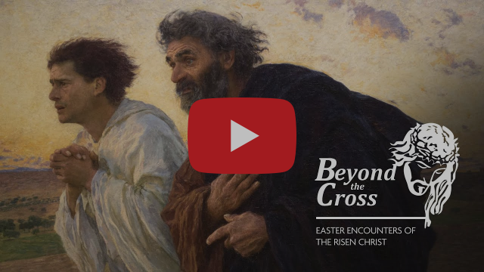](https://rcsouthwark.us11.list-manage.com/track/click?u=a40ab1a35eac7236d856fe882&id=82506f85a7&e=7d4ac57aff)

**WATCH ‘BEYOND THE CROSS’**

'Beyond the Cross'is a five-part art and culture series produced by the Catholic Bishops' Conference of England and Wales.  It follows on from 'At the Foot of the Cross', which considered four famous paintings telling the story of Christ's Passion and Resurrection. 'Beyond the Cross' follows the Risen Christ through the artist's eye taking in some of the main encounters of the season of Easter.

In the video (see below) the viewer is asked to look at the empty tomb and take as inspiration the Swiss painter Eugene Burnand's 1898 work 'The Disciples Peter and John Running to the Sepulchre on the Morning of the Resurrection'.

**LAUDATO SI’ WEEK**

|  |
| --- |
| Laudato Si’ Week is being celebrated from May 16-24. As part of it, the Global Catholic Climate Movement will be holding a series of special events to mark the Laudato Si’ anniversary year.  This will be a celebration of the progress the whole Church has made on its journey to ecological conversion. The week will include prayer gatherings, music, discussions about energy and fossil fuels, and a presentation on the Care of Creation. View the full programme and register interest here: [LaudatoSiWeek.org](https://rcsouthwark.us11.list-manage.com/track/click?u=a40ab1a35eac7236d856fe882&id=ab22cf3180&e=7d4ac57aff) |

**MARY’S MEALS: 1.8M BENEFIT**

Since its humble beginnings, Mary’s Meals, named after Mary the Mother of Jesus, has been built on a foundation of prayer and the many little acts of love from those who support it.

During May, the month traditionally dedicated to Our Lady, you are invited to join in prayer to celebrate the wonderful work of Mary’s Meals.

Give thanks that more than 1.8 million children in 19 countries are receiving a nutritious meal every school day as a result.

Inspirational resources for the Pray In May campaign, including a prayer card, can be found on [our website](https://marysmeals.us18.list-manage.com/track/click?u=71642ed3d70deb2b1c25da8f0&id=1c30715a38&e=ef965371e1).

**VACANCY AT ST PHILOMENA’S**

The governors of St Philomena’s Catholic high school for girls in Carshalton are seeking to appoint a clerk to the governing body.

This is a paid position, 310 hours a year, term time only.

You can find out more and obtain an application form by emailing [recruitment@stphils.org.uk](mailto:recruitment@stphils.org.uk) or phoning 020 8642 2025. Or visit the school’s website:

<http://www.stphils.org.uk/join-us/vacancies>

**PLEASE DON’T FORGET…**

Keeping everyone safe when they come to Mass at St Columba’s is essential.

Using the defogger, a piece of machinery we now have for sanitizing the benches after Sunday Mass, is part of that.

It’s much easier and quicker for the stewards to use this electrically-operated spray than cleaning and drying by hand as they did before.

At Mass, remember to leave plenty of space between you in the bench.

There should be no more than three people – unless you are a family or in a bubble – ideally one person at each end, one in the middle.

During the week, take a marker paper when arriving and leave it on the seat so that it’s obvious which part of the bench needs manual cleaning.

Do please be prepared to lend a hand helping the stewards clean the benches after weekday Masses.



**WALSINGHAM ROSARY MISSION**

Catholics in England, Wales and Scotland are invited during May (if possible, each evening at 8pm) to pray the Rosary for the following intentions:

1. Protecting our families and the family of nations, especially in this Year of St Joseph;

2. A deepening of faith, hope, love and the protection of life;

3. Peace in the world;

4. Deliverance from Coronavirus; for those working for a cure; for those who have died; for those who are suffering and those who care for them.

The designated Rosary Hour for our diocese of Southwark for the National Rosary Relay Rally is Sunday May 30 from 3-4pm. For more details go to:

<https://www.walsingham.org.uk/2021/04/26/may-2021-rosary-mission/>

**RENATE FILM COMPETITION**

RENATE stands for Religious in Europe Networking Against Trafficking and Exploitation.

It is inviting 16-24-year-olds in European countries to join its mission to tackle human trafficking by entering a film competition.

RENATE encourages young people to get involved by producing a short film individually or as part of a team, up to four minutes long, around the slogan ‘Slavery - Human Trafficking - Near YOU!', and some or all of the following tags: #StopTheDemand, #BreakTheChains, #EndTheCycleTOGETHER.

The deadline date of entry is mid-August 2021.

For more information visit this website:

[www.renateevents.net/film-competition](http://www.renateevents.net/film-competition)

**THE COVID CRISIS IN INDIA**

As coronavirus brings devastation across India, CAFOD is working with experienced local Church agency Caritas India to provide vital support to poor and marginalised communities.

Donations to CAFOD’s Coronavirus Appeal will help Caritas India distribute PPE kits to frontline health workers, promote COVID and vaccine awareness campaigns and set up safely-run isolation and quarantine centres.

You can donate online by using this website link: [cafod.org.uk/give](https://cafod.org.uk/Give).

Please keep praying for the people of India and all those affected by the pandemic.

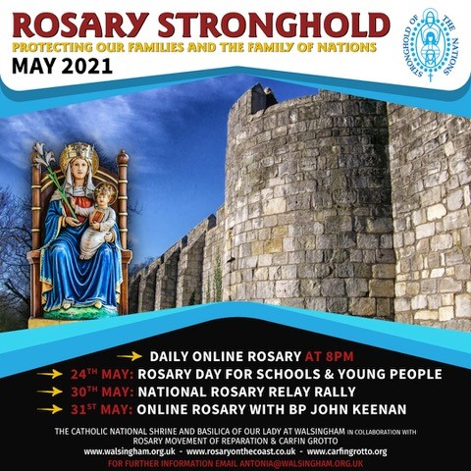

**ROSARY STRONGHOLD**

In addition to the [Pentecost Novena for the Care of Creation](https://rcsouthwark.us11.list-manage.com/track/click?u=a40ab1a35eac7236d856fe882&id=b272f46a8b&e=7d4ac57aff) (May 16-24), the **Catholic Bishops' Conference of England and Wales** are releasing short podcasts of the Hail Mary being prayed in a different language every day. [Visit their Facebook page.](https://rcsouthwark.us11.list-manage.com/track/click?u=a40ab1a35eac7236d856fe882&id=3e5bfece8b&e=7d4ac57aff)  
  
**The Rosary Stronghold** [convenes each evening at 8 pm](https://rcsouthwark.us11.list-manage.com/track/click?u=a40ab1a35eac7236d856fe882&id=812775ffa4&e=7d4ac57aff) and, alongside praying for faith, life and peace, the organisers also join in prayer with the Holy Father's Rosary Mission to invoke an end to the COVID-19 pandemic.

They have arranged three special events in the latter half of May, and would particularly like to highlight the [Rosary Day for Schools and Young People](https://rcsouthwark.us11.list-manage.com/track/click?u=a40ab1a35eac7236d856fe882&id=ad74d7fe8a&e=7d4ac57aff) on

24th May, when they ask that the rosary be prayed in schools.

They also wish to encourage the faithful to intercede for all young people, their intentions and our Catholic schools' mission. [Watch this video](https://rcsouthwark.us11.list-manage.com/track/click?u=a40ab1a35eac7236d856fe882&id=09f674bd5e&e=7d4ac57aff) to find out more. 



**DEFENDING RELIGIOUS FREEDOM**

Aid to the Church in Need is joining forces with Catholic Voices to host a webinar on Wednesday May 19 from 6-7.30pm to explore the issue of standing up for religious freedom.

That is in particular in the context of current events such as growing religious persecution in countries such as China and Nigeria, international relations, COVID restrictions, and digital media.  
The event, which will be chaired by ACN(UK)’s Head of Press & Information John Pontifex, will feature invited speakers including:

* Archbishop John Wilson
* Baroness Helena Kennedy QC of the Shaws
* Professor the Lord David Alton of Liverpool
* Father Habila Daboh, Seminary rector of Kaduna, northern Nigeria, who will give testimony following the abduction of four of his students, the youngest of whom, Michael Nnadi, 18, was killed.

This webinar promises to be both lively and engaging.  [Register here](https://rcsouthwark.us11.list-manage.com/track/click?u=a40ab1a35eac7236d856fe882&id=381c8469bd&e=7d4ac57aff)

**THE DAY OF THE LORD**

**The bishops of England and Wales have come together to provide a reflection entitled ‘The Day of the Lord’.**

**Its purpose is to pay tribute to all in the Catholic community ‘who have shown such courage, generosity and understanding in the face of adversity this past year’.**

**Click on this link to access the reflection: **

**ELABORATING THE DIVINE**

This is a series of online evening talks exploring some of the great themes of Catholic Christianity in writing old and new, with Catholic scholars and contemporary authors.

They take place every second Thursday at 7.30pm. The next webinar is on May 27. For information and registration click on this link:

<https://christianheritagecentre.com/events/logos-and-literature/>

**THE LONDON JESUIT CENTRE**

Here are details of forthcoming events at the London Jesuit Centre:

Every week, Monday to Thursday, the Heythrop Library is now open again.

June 19: ‘An Opportunity for Prayer’ - a retreat from 2-4pm

June 21: Brian Purfield’s ‘Introduction to the Bible – morning and evening classes on offer.

More details from: [www.londonjesuitcentre.org](https://londonjesuitcentre.us4.list-manage.com/track/click?u=ba5b3aa1bbd112142962fd5fd&id=fe4386ac1c&e=c39c69b4e0)

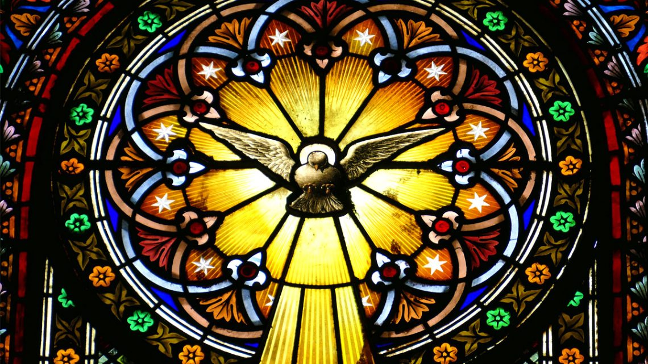

**THE MEANING OF PENTECOST**

The God Who Speaks project team has been busy compiling a number of interesting articles for Pentecost.

They include an exploration of the Holy Spirit as the animator of the Church, written by Canon Chris Thomas, as well as a Novena for Creation and a piece by Fleur Dorrell which considers the Christian imagery and theology of the Dove. [Read more](https://rcsouthwark.us11.list-manage.com/track/click?u=a40ab1a35eac7236d856fe882&id=399b41a157&e=7d4ac57aff)