**St Columba’s Church, Selsdon**

37 Queenhill Road, Selsdon, South Croydon, CR2 8DW

Parish telephone number: 020 8657 3747

Parish Priest: Father Roy Tablizo

E: [selsdon@rcaos.org.uk](mailto:selsdon@rcaos.org.uk)

Deacon: Rev. Philip Pond E: [philippond@rcaos.org.uk](mailto:philippond@rcaos.org.uk)

T: 020 8651 4653

Parish website: [www.stcolumbaschurchselsdon.uk](http://www.stcolumbaschurchselsdon.uk)

**23rd MAY 2021**

**PENTECOST SUNDAY (YEAR B)**

**THIS SUNDAY’S MASS READINGS**

**Entrance Antiphon:** The Spirit of the Lord has filled the whole world and that which contains all things understands what is said, alleluia.

**A reading from the Acts of the Apostles: 2:1-11**

**Responsorial Psalm PS 103:1. 24. 29-31. 34. Rcf. V.30:** Send forth your Spirit, O Lord, and renew the face of the earth.

**2nd Reading: A reading from the letter of St Paul to the Galatians: 5:16-24**

**Gospel Acclamation:** Alleluia, Alleluia! Come, Holy Spirit, fill the hearts of your faithful and kindle in them the fire of your love. Alleluia!

**Gospel: John 15:26-27; 16:12-15**

**Communion Antiphon:** They are all filled with the Holy Spirit and spoke of the marvels of God, alleluia.

**COVID PRECAUTIONS AT MASS: NOTE THE CHANGES**

In line with the Government’s Covid road map to normalisation, our Archbishop, John Wilson, has relaxed some of the restrictions placed on the celebration of Mass.

We can now once again have the Prayer of the Faithful (Bidding Prayers).

Holy Communion can be distributed with the usual invitation by the minister and response by the communicant: ‘Body of Christ – Amen’.

Holy Communion will still, however, continue to be given in the hand only and after Mass ends.

Don’t forget that we now have exposition and adoration of the Blessed Sacrament every Tuesday morning after 10am Mass.

The Novena to Our Lady on Saturday mornings has also restarted: from 10-10.20am. Everyone is invited.

A PASTORAL LETTER FOR PENTECOST FROM ABP. JOHN WILSON

Dear Brothers and Sisters in Christ,

The Solemnity of Pentecost reminds us that everything which exists, every person and the whole of creation, is a gift of “God the Father almighty, Creator of heaven and earth.” God our loving Father creates and continues to give life to the world through His Word, Jesus Christ, in the power of His Holy Spirit. The outpouring of the Holy Spirit on the Church, which we celebrate at Pentecost, is not something separate from Creation. God’s revelation of himself in Creation is inseparable from the revelation of his love for us in Christ and in his desire to live in us through his Holy Spirit.

‘God’s Spirit is always and everywhere “the Lord, the Giver of Life”, and the voice of Pentecost is echoed in the voice of creation being transformed into the glorious liberty of God’s children.’ In this liberty, as God’s children, we call on the Spirit to ‘renew the face of the Earth’, and as his children, we are called, in turn, to use this liberty for the good of creation and for the good of all that brings life. Our world, God’s creation, is a precious gift to us. It is our common home entrusted to each generation. But how have we used that glorious liberty? How do we honour this precious gift? Are we really demonstrating love, care and respect for our common home?

As we celebrate Pentecost this year, we are acutely aware of the damage that continues to be inflicted on the Earth, and the repercussions for the well-being of our brothers and sisters, both here in our own countries and, more especially, in the poorest countries of our world. Pope Benedict XVI and Pope Francis have both taught us that everything is interconnected and interdependent. The way we live our everyday lives has an impact on everyone and on the earth.

The urgency of the situation, and the enormity of the challenges we face, have spurred us to speak out together this Pentecost Sunday, as bishops of England, Wales and Scotland, about the role that the Catholic Church and our faith must play in our shared care for God’s gift to us.

For all too long we have either been ignorant of, or ignored, the systematic exploitation of our planet and the unsustainable consumption of its resources. While accepting the crucial need and demand for energy for the benefit of the poorest of our brothers and sisters, the provision of our energy must, nonetheless, be by means which radically reduce the use of carbon-based fuels.

In our political thinking, there must be a new global understanding of our world, where nations recognise our common responsibility for the dignity of all people and their rights to sustainable livelihoods, in authentic freedom. Pope Francis speaks of a global politics that looks beyond our own needs to the needs of all, most especially the poor and the marginalised.

But we cannot leave the healing of our common home and the wellbeing and care of our brothers and sisters merely to a response from industry and governments. Our own local concern and action is necessary and has far-reaching consequences. We all have a part to play, each and every one of us, in the routines, choices and decisions of our everyday lives and our aspirations for the future. The actions of parishes, families, schools, and individuals will have a significant impact on our efforts to restore our common home. There are now many resources, freely available, to advise us on our choice of food, saving of water and electricity, suggestions about travel, waste, and re-use. These are measures that everyone can employ, in some degree, with minimal inconvenience and change. They are effective ways in which we can each reaffirm our personal vocation to be stewards of creation.

This Pentecost comes at a time of remarkable challenge and opportunity. We are gradually emerging from the tragedies and restrictions of the pandemic. We have the ability to make changes. Our countries are also hosting two most important meetings this year, the G7 in June and COP26 in November. These meetings will gather together men and women who have the power to make defining choices and policies which will help us build back better, provide for our brothers and sisters, and take care of our common home.

In all our human endeavours, we need the presence of the Holy Spirit, “the Lord, the Giver of Life”, whose gift to the Church and the world we celebrate again at Pentecost. Let us keep this Feast with that enduring hope that we can begin to repair the damage we have done and provide a healthy home for future generations. Our hope will be strengthened by our prayer. May our constant request be that the Holy Spirit guide us, strengthen our resolve and ‘renew the face of the earth’.

**REMEMBER THE SICK AND NEEDY**

Please pray for all those who are sick or in need at this time including: Howard Francis, Douglas & Yvonne Bruce, Stephen Beck, Colin Furk, Vera De Souza, Mike Bond, Alice Barclay, Thelma Benn, Julie Ballesteros, Cora Litchfield, Sean Walsh, Judy Freegard, Imogen Fernando, Joan Cunningham, Solveya La Marina, Chris Jones, Maria Reece, Margaret Bolton, Eddie Aldridge, Ellis Warburton, Mary Marks, Jean-Claude Anthony, Ellen Everett, Maureen Coffey, James Guckian, Elizabeth Sensano and sick residents at the four residential homes usually, in better times, visited by the parish St Vincent de Paul group.

|  |  |
| --- | --- |
| **LITURGICAL CALENDAR OF THE WEEK** | |
| Sat 22nd | Weekday of Easter or Saint Rita of Cascia, Religious |
| Sun 23rd | Pentecost Sunday |
| Mon 24th | Mary, Mother of the Church |
| Tues 25th | St Bede the Venerable, Priest, Doctor of the Church (memorial (E)), Weekday of Ordinary Time, or Gregory VII, Pope, St Mary Magdalene de’Pazzi, Virgin |
| Wed 26th | WSt Philip Neri, Priest |
| Thurs 27th | Our Lord Jesus Christ, Eternal High Priest |
| Fri 28th | Weekday of Ordinary Time |
| Sat 29th | Weekday of Ordinary Time or St Paul VI, Pope |
| Sun 30th | The Most Holy Trinity |

**SOME DEFINITE SERVICE**

Our Archbishop John is calling the Archdiocese of Southwark to be an ‘evangelising and missionary archdiocese.’

What does that mean?

As part of an answer to this call the Agency for Evangelisation and Catechesis (AEC) is developing a missionary volunteer network consisting of prayer, people and parish plans – *Some Definite Service.* What might be your particular part to play in this, some definite service?

For more information, visit: aec.rcaos.org.uk/sds

|  |  |  |
| --- | --- | --- |
| **MASS INTENTIONS FOR THE WEEK** | | |
| Sat 22nd | 6.30pm | Pro populo |
| Sun 23rd | 8.00am | Jessica Harvey, RIP |
| Sun 23rd | 10.00am | Helga & Theo Schroder, RIP |
| Sun 23rd | 6.30am | Private Intention (Coulsdon Catenians) |
| Mon 24th | 10.00am | Kathleen O’Halleron, RIP |
| Tues 25th | 10.00am | Diago Paes, RIP (Maria & Mario D’Souza) |
| Wed 26th | 10.00am | Mrs Teresa Curran, RIP |
| Thurs 27th | 10.00am | Mr & Mrs Benedict, RIP |
| Fri 28th | 10.00am | Departed members of & those cared for by the Ligory Family |
| Sat 29th | 6.30pm | Pro populo |
| Sun 30th | 8.00am | Cora Litchfield, wellbeing |
| Sun 30th | 10.00am | Cosimira Ramos, wellbeing |
| Sun 30th | 6.30pm | Dani Gonek, wellbeing |

***DON’T FORGET, EVERY TIME YOU COME TO CHURCH…***

We know we must take precautions when coming to Mass. They are set by the Government – and the local council is checking that we comply.

So every time you come to church make sure to:

* Remember to bring and wear a face mask covering the nose as well as the mouth. There are some available in church if you forget.
* Enter the church via the side door leading into the Sacred Heart chapel/confessional, observe the one-way system and leave via the centre back door.
* Meet Track-and-Trace requirements by providing a written note every time you come to church of your name and contact details plus the date and, if relevant, Mass time. To save queuing and filling out a form, send an email to selsdon@rcaos.org.uk
* Use hand sanitizer, provided, both when entering and leaving the church.
* Take a paper marker (during the week, not at the weekend) and leave it on your seat so that the stewards know where to sanitize.
* Leave where they are the chairs which have replaced some of our benches and are at 1m intervals to ensure the necessary social distancing.
* Bring your own Mass or prayer book – there are no shared items.
* Leave the church straight after Holy Communion and don’t congregate outside to socialise.

**WANT TO GO TO CONFESSION?**

Well you can – and at the same time be confident that you are safe from Covid. Simply give Fr Roy a ring and make an appointment. He will hear your confession in private in the hall.

***IF YOU TEST POSITIVE FOR COVID…***

Should that happen and you have been to Mass at St Columba’s in the preceding week, let Fr Roy or Deacon Philip know. For track’n’trace purposes, they may then need to contact anyone else who was at the same Mass. That’s when the track’n’trace forms which everyone attending Mass has to complete (unless they send an email) come into play

**FIRST COMMUNION & CONFIRMATION**

First Communions will take place on Sunday June 27 at noon.

A dozen children are now being prepared for their first Holy Communion (and Sacrament of Reconciliation). Please keep them all in your prayers.

CONFIRMATIONS Young people (age 13-14) wishing to receive the Sacrament of Confirmation are advised to write a short letter to Fr Roy asking to be confirmed.

Instruction is planned to start in June – the date will be announced shortly. Watch this space.

**LIFE IN THE SPIRIT**

A series of Life in the Spirit seminars is being organised for personal and diocesan renewal over coming weeks.

Each attendee will be invited to grow in their love of the Lord, welcome the Spirit into their lives afresh and pray for the renewal of our diocese.

Taking place on Tuesday evenings from 8-9.30pm, the seminars will feature a talk from a gifted speaker and small group sharing.

Details are as follows.

May 25, speaker: Archbishop John Wilson  
June 1, speaker: Kathryn Murrell

To book for the seminars please click on this link:   
[Book here](https://rcsouthwark.us11.list-manage.com/track/click?u=a40ab1a35eac7236d856fe882&id=89b6876049&e=087693309e)



***SHOP ONLINE AND HELP ST C’S TOO***

Thinking of buying something online? Anything? A new washing machine or any other white goods?

Or perhaps you need a new vacuum cleaner or intend ordering a book or dvd or other items.

If you do it online you can help St Columba’s finances, depleted by the lockdown, at the same time and at no cost to yourself.

More and more parishioners are signing up for this scheme. It means that you can turn your everyday online shopping into free donations to our parish.

It’s simple. It’s straightforward. And it will cost you nothing.

All you have to do is to logon to the following website [www.easyfundraising.org.uk](http://www.easyfundraising.org.uk), register (which is quick and easy) and then go shopping online at whichever retailer you choose. Then, in future, every time you buy something – anything – a small donation is made to St Columba’s.

|  |  |  |
| --- | --- | --- |
| There are more than 4,000 retailers to choose from including lots of big names such as Argos, John Lewis, Amazon, M&S and Sainsbury’s.  Have a look at this link to find out more: [https://www.easyfundraising.org.uk/causes/stcolumbasldn/?invite=ZTUSO0%26referral-campaign=c2s%26utm_campaign=admin-trigger%26utm_content=nst](http://t.e.easyfundraising.org.uk/r/?id=h2ef6bab4,257a256b,25302fff&utm_source=adobecampaign&utm_medium=email&utm_campaign=referral-2018&utm_content=trigger-supp-referee-raised-2018&origin=RTNS2&p1=stcolumbasldn&p2=ZTUSO0)  **DEAR HUSBAND & WIFE…**  You are invited to give each other a gift by spending July 10 online between 9am and 1pm exploring and improving your relationship.  The event, entitled ‘Building A Better Marriage’, will provide you with valuable insights into your communication skills and the call of the Church to the married.  There is no group sharing.  This is not marriage counselling but a chance to make average-to-good marriages a bit better – whether you married five years ago or 50.  Booking is essential: telephone 07983 524 727 or email [mflkent@rcaos.org.uk](mailto:mflkent@rcaos.org.uk)  Recent online ‘Building a Better Marriage’ courses attracted the following comments from couples: ‘The topics were chosen well and we could really relate to them… The personal stories you shared were very insightful and helped us to reflect on our own relationships more deeply… It was relaxed and you put us at ease, being friendly and personable... We thoroughly enjoyed attending the course.’    **ANNUAL MARRIAGE MASS**  Are you celebrating your 1st, 10th, 25th, 40th, 50th, 60th or any later wedding anniversary this year?  Or did you last year?  If so, Archbishop John invites you to join him in celebrating a Mass for married couples at 3pm on Saturday October 9 at St George’s Cathedral.  You need to book in advance and by doing so you will then receive a personal written invitation from Archbishop John.  To book or for more details email [mflsw@rcaos.org.uk](mailto:mflsw@rcaos.org.uk)  **HOW DID COVID AFFECT YOU?**  Our diocesanAgency for Evangelisation and Catechesis has partnered with other dioceses to produce and promote a survey which aims to find out about the experiences of Catholics over the period of the Coronavirus pandemic.  This research will help us to understand what has been happening during this time when churches have been closed and/or only opened for limited periods and Catholics have had to practice their faith ‘at a distance’. To complete the survey, select our Archdiocese from the drop-down menu so that we can hear about what God has been doing and what He wants to say to us about the future of the Church in this part of England and Wales.  This important survey should take about 10 minutes to complete and the deadline for submissions for Southwark is July 4. Click on this link:  <https://forms.rcaos.org.uk/covid-19-survey-form/>  **SO WHAT’S YOUR VERDICT?**  **On our newsletter, that is.**  **Your comments, thoughts, suggestions, ideas and contributions would be most welcome.**  **They will also enable us to know whether this newsletter is considered helpful and useful – or not. Email Deacon Philip – the deadline for each weekend’s newsletter is the Wednesday before.** |  |  |

**GOT YOUR GIFT AID ENVELOPES?**

**There are still plenty waiting to be collected…**

**All members of the Gift Aid scheme are invited this weekend to collect their boxes of envelopes for the coming year.**

**The boxes, with your names on, can be collected at the entrance to the sacristy in the Sacred Heart chapel after all Masses.**

**Don’t forget to take yours…**

**THINK YOU HAVE A VOCATION?**

The Beda College in Rome is running a discernment weekend for men between the ages of 30 and 55 from September 3-5.

It takes place at St Beuno’s Spirituality Centre in North Wales.

The weekend is a first step for those who may be exploring the possibility of priestly vocation in later life.

Information and registration forms are at: <https://www.pathwaystogod.org/courses-events-retreats/discernment-weekend-older-men-1>

**KNOW OF ANYONE IN NEED?**

Are you aware of any parishioners living alone or in need?

If so, as well as phoning them yourself occasionally to see if they need anything, let Fr Roy or Deacon Philip know of their situation.

That way, we can work together to support and help them at this difficult time.

**ST JOSEPH’S 150TH ANNIVERSARY**

In preparation for the 150th anniversary of the opening of St Joseph’s School, Upper Norwood, former pupils, parents, staff, governors and friends are invited to submit recollections, photos and memorabilia.

They will be displayed in anniversary publications and at events.

Please include a description of any items sent, name people in photos and add a date or occasion when the photograph might have been taken.

During the celebratory year, beginning in September, there will be many opportunities to visit St Joseph’s and to meet with other alumni to mark this special milestone.

Please help spread the news to all those associated with St Joseph’s, both the primary and secondary schools.

To share memories of your days at St Joseph’s or to receive more information as plans for the anniversary year unfold, please email your contact details to: [alumni@st-josephs-jun.croydon.sch.uk](mailto:alumni@st-josephs-jun.croydon.sch.uk)

For more details visit the school’s website: <https://www.stjosephsfederation.co.uk/>

**GOING INTO HOSPITAL? TELL US**

If you or a member of your family go into hospital, ask the Ward Sister or Staff Nurse to notify the hospital’s Roman Catholic hospital chaplain direct.

That will make it much more likely that you have the opportunity of receiving Holy Communion (or any other sacraments) while in hospital.

Make sure also to let Fr Roy or Deacon Philip know beforehand if possible of your admission or that of a family member into hospital.

We can then keep you in our prayers.

[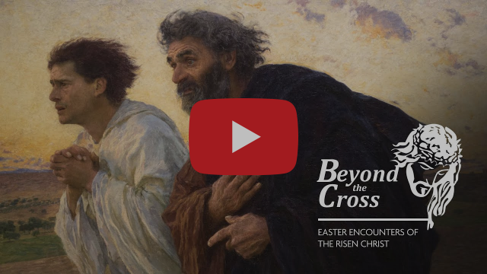](https://rcsouthwark.us11.list-manage.com/track/click?u=a40ab1a35eac7236d856fe882&id=82506f85a7&e=7d4ac57aff)

**WATCH ‘BEYOND THE CROSS’**

'Beyond the Cross'is a five-part art and culture series produced by the Catholic Bishops' Conference of England and Wales.  It follows on from 'At the Foot of the Cross', which considered four famous paintings telling the story of Christ's Passion and Resurrection. 'Beyond the Cross' follows the Risen Christ through the artist's eye taking in some of the main encounters of the season of Easter.

In the video (see below) the viewer is asked to look at the empty tomb and take as inspiration the Swiss painter Eugene Burnand's 1898 work 'The Disciples Peter and John Running to the Sepulchre on the Morning of the Resurrection'.

**PLEASE DON’T FORGET…**

Keeping everyone safe when they come to Mass at St Columba’s is essential.

Using the defogger, a piece of machinery we now have for sanitizing the benches after Sunday Mass, is part of that.

It’s much easier and quicker for the stewards to use this electrically-operated spray than cleaning and drying by hand as they did before.

At Mass, remember to leave plenty of space between you in the bench.

There should be no more than three people – unless you are a family or in a bubble – ideally one person at each end, one in the middle.

During the week, take a marker paper when arriving and leave it on the seat so that it’s obvious which part of the bench needs manual cleaning.

Do please be prepared to lend a hand helping the stewards clean the benches after weekday Masses.

**RENATE FILM COMPETITION**

RENATE stands for Religious in Europe Networking Against Trafficking and Exploitation.

It is inviting 16-24-year-olds in European countries to join its mission to tackle human trafficking by entering a film competition.

RENATE encourages young people to get involved by producing a short film individually or as part of a team, up to four minutes long, around the slogan ‘Slavery - Human Trafficking - Near YOU!', and some or all of the following tags: #StopTheDemand, #BreakTheChains, #EndTheCycleTOGETHER.

The deadline date of entry is mid-August 2021.

For more information visit this website:

[www.renateevents.net/film-competition](http://www.renateevents.net/film-competition)

**THE COVID CRISIS IN INDIA**

As coronavirus brings devastation across India, CAFOD is working with experienced local Church agency Caritas India to provide vital support to poor and marginalised communities.

Donations to CAFOD’s Coronavirus Appeal will help Caritas India distribute PPE kits to frontline health workers, promote COVID and vaccine awareness campaigns and set up safely-run isolation and quarantine centres.

You can donate online by using this website link: [cafod.org.uk/give](https://cafod.org.uk/Give).

Please keep praying for the people of India and all those affected by the pandemic.

**GOING BACK TO MASS**

**The bishops of England and Wales have produced a reflection entitled ‘The Day of the Lord’ linked to returning to Mass after the pandemic**

**Its purpose is to pay tribute to all in the Catholic community ‘who have shown such courage, generosity and understanding in the face of adversity this past year’.**

**Click on this link to access the reflection: **

**ELABORATING THE DIVINE**

This is a series of online evening talks exploring some of the great themes of Catholic Christianity in writing old and new, with Catholic scholars and contemporary authors.

They take place every second Thursday at 7.30pm. The next webinar is on May 27. For information and registration click on this link:

<https://christianheritagecentre.com/events/logos-and-literature/>

**THE LONDON JESUIT CENTRE**

Here are details of forthcoming events at the London Jesuit Centre:

June 19: 2-4pm ‘An Opportunity for Prayer’ - a retreat

June 21: Brian Purfield’s ‘Introduction to the Bible – morning and evening classes on offer.

More details from: [www.londonjesuitcentre.org](https://londonjesuitcentre.us4.list-manage.com/track/click?u=ba5b3aa1bbd112142962fd5fd&id=fe4386ac1c&e=c39c69b4e0)

**THANK YOU FOR YOUR OFFERING**

The Offertory collection for May 9 totalled £609.52 of which £262 was Gift Aided and £347.52 not.

The Offertory collection for May 16 totalled £517.11 of which £269.86 was Gift Aided and £247.25 not.

In addition £122.45 was received for Repository items.

**40 YEARS OF THE PASSAGE**

Cardinal Vincent Nichols will celebrate the 5.30pm Mass at Westminster Cathedral on Tuesday (May 25) to mark 40 years of service provided to homeless people through The Passage charity.

The Mass will be broadcast live online, so if you would like to follow the service from home, the link is: <https://www.westminstercathedral.org.uk/>

If you would like to attend the Mass in person, this may be possible, but the Cathedral has a strict limit under the current Covid regulations.

Please register your interest with us and we will let you know on Monday if a place is available - email [andrew.h@passage.org.uk](mailto:andrew.ho@passage.org.uk)

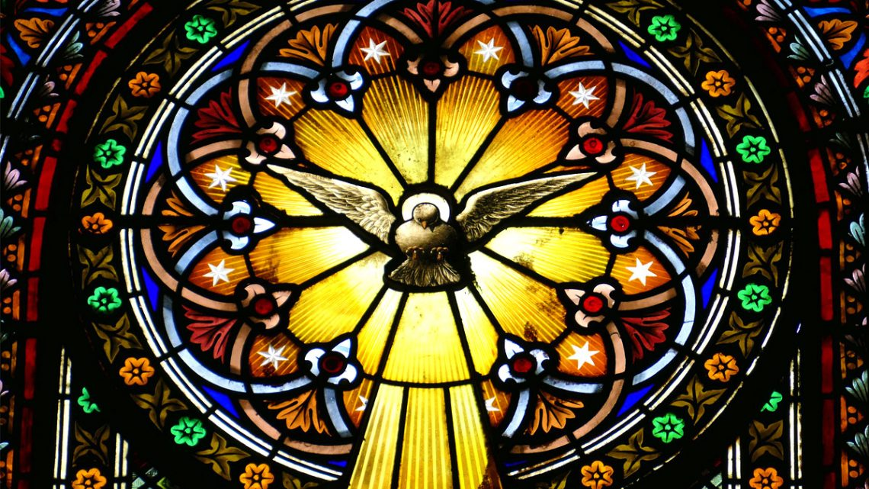

**THE MEANING OF PENTECOST**

The God Who Speaks project team has been busy compiling a number of interesting articles for Pentecost which we celebrate this weekend.

They include an exploration of the Holy Spirit as the animator of the Church, written by Canon Chris Thomas, as well as a Novena for Creation and a piece by Fleur Dorrell which considers the Christian imagery and theology of the Dove. [Read more](https://rcsouthwark.us11.list-manage.com/track/click?u=a40ab1a35eac7236d856fe882&id=399b41a157&e=7d4ac57aff)