**St Columba’s Church, Selsdon**

37 Queenhill Road, Selsdon, South Croydon, CR2 8DW

Parish telephone number: 020 8657 3747

Parish Priest: Father Roy Tablizo

E: [selsdon@rcaos.org.uk](mailto:selsdon@rcaos.org.uk)

Deacon: Rev. Philip Pond E: [philippond@rcaos.org.uk](mailto:philippond@rcaos.org.uk)

T: 07764 845 890

Parish website: [www.stcolumbaschurchselsdon.uk](http://www.stcolumbaschurchselsdon.uk)

**25 APRIL 2021**

**4th SUNDAY OF EASTER (YEAR B)**

**THIS SUNDAY’S MASS READINGS**

**Entrance Antiphon:** The merciful love of the Lord fills the earth; by the word of the Lord the heaveans were made, alleluia.

**A reading from the Acts of the Apostles: 4:8-12**

**Responsorial Psalm PS 117:1. 8-9. 21-23. 26. 28-29. Rv22:** The stone which the builders rejected has become the corner stone.

**2nd Reading: A reading from the first letter of St John: 3:1-2**

**Gospel Acclamation:** Alleluia, Alleluia! I am the good shepherd, says the Lord; I know my own sheep and my own know me. Alleluia!

**Gospel: John 10:11-18**

**Communion Antiphon:** The Good Shepherd has risen, who laid down his life for his sheep and willingly died for his flock, alleluia.

**ESSENTIAL WORK IN CHURCH**

Keeping everyone safe when they come to Mass at St Columba’s is essential. Using the defogger, a piece of machinery we now have for sanitizing the benches after Sunday Mass, is part of that.

It’s much easier and quicker for the stewards to use this electrically-operated spray than cleaning and drying by hand as they did before.

At Mass, remember to leave plenty of space between you in the bench. There should be no more than three people – unless you are a family or in a bubble – ideally one person at each end, one in the middle.

During the week, take a marker paper when arriving and leave it on the seat so that it’s obvious which part of the bench needs manual cleaning.

Do please be prepared to lend a hand helping the stewards clean the benches after weekday Masses.

As the good shepherd, Jesus challenges us to follow his example

*A reflection on Sunday’s Gospel by Fr Roy*

This Sunday’s gospel shows us an image of the care and love of Jesus as the good shepherd.

His willingness to lay down his life is a dramatic indication of his love and care; his death on the cross, the ultimate sacrifice.

It reveals the genuineness of God’s love.

Jesus did not have second thoughts about this death because he knew that it was the only way for us to understand his mission.

He wants us to realise that death to self is not something that we have to be afraid of or dread.

The reward that awaits us in heaven completely outweighs the pain of self-denial.

So we need to be brave about giving up our life to God.

We should never have regrets about missing out on anything that the world has to offer because they are all empty promises.

Jesus, instead, offers us something substantial that will last beyond our earthly life.

His alternative is beyond compare because the satisfaction it promises is heavenly and eternal.

The powerful image of the good shepherd deserves our attention.

In it Jesus reveals to us the purity of God’s love; his desire to lead us back to the right path.

Remember, however, that this journey back to him can never take place without our consent and participation.

It demands an effort on our part to commit and listen to his voice.

The relationship between the shepherd and the sheep shows us the level of understanding between the two parties.

The shepherd does not have to say anything because the movements of his hands and the expression on his face are discerned by the sheep and prompt them to do as he wants.

The level of intimacy between shepherd and sheep deserves closer examination.

The sheep instinctively know that the shepherd will never put their lives in danger.

So they trust him implicitly, knowing that he would be willing to lay down his life for them.

This is the image that Jesus wants us to see in this gospel, his willingness to lay down his life for us.

The personal relationship between sheep and shepherd is a lesson to us to develop the same level of trust and confidence in God.

By dying on the cross, Jesus paid the price for our sins. His death was the ransom for our salvation.

The cross is the call Jesus makes to all believers.

His death is our gain because heaven is opened to us as a result.

Never forget that the journey to heaven is never easy.

We must take the same route that Jesus walked. Remember too that the way of the cross is crucial to the story of resurrection.

In effect, Jesus is challenging each of us to review our individual path and find out how we can integrate his way of the cross into our individual life.

Jesus marked out for us the path taken by the good shepherd.

So on our journey we must follow the example of the good shepherd.

In order to do that we need to listen to his voice.

***KEEPING YOU SAFE WHEN YOU COME TO MASS***

We know we must take precautions when coming to Mass. They are set by the Government – and the local council is checking that we comply.

So every time you come to church make sure to:

* Remember to bring and wear a face mask covering the nose as well as the mouth
* Enter the church via the side door leading into the Sacred Heart chapel/confessional, observe the one-way system and leave via the centre back door.
* Meet Track-and-Trace requirements by providing a written note every time you come to church of your name and contact details plus the date and, if relevant, Mass time. To save queuing and filling out a form, send an email to selsdon@rcaos.org.uk
* Use hand sanitizer, provided, both when entering and leaving the church.
* Take a paper marker (during the week, not at the weekend) and leave it on the bench so that cleaners know which part to clean.
* Leave where they are the chairs which have replaced some of our benches and are at 1m intervals to ensure the necessary social distancing.
* Bring your own Mass or prayer book – there are no shared itemsl.
* Keep silent when receiving Holy Communion.
* Leave the church straight after Holy Communion and don’t congregate outside to socialise.

|  |  |
| --- | --- |
| **LITURGICAL CALENDAR OF THE WEEK** | |
| Sat 24th | Weekday of Easter or Saint Fidelis of Sigmaringen, Priest, Martyr; (St Adalbert, Bishop, Martyr) |
| Sun 25th | 4th Sunday of Easter |
| Mon 26th | Weekday of Easter |
| Tues 27th | Weekday of Easter |
| Wed 28th | Weekday of Easter or Saint Peter Chanel, Priest, Martyr; St Louis Marie Grignion de Montfort, Priest |
| Thurs 29th | St Catherine of Siena, Virgin, Doctor of the Church, patron of Europe |
| Fri 30th | Weekday of Easter or St Pius V, Pope, Religious |
| Sat 1st | Weekday of Easter or Saint Joseph the Worker |
| Sun 2nd | 5th Sunday of Easter |

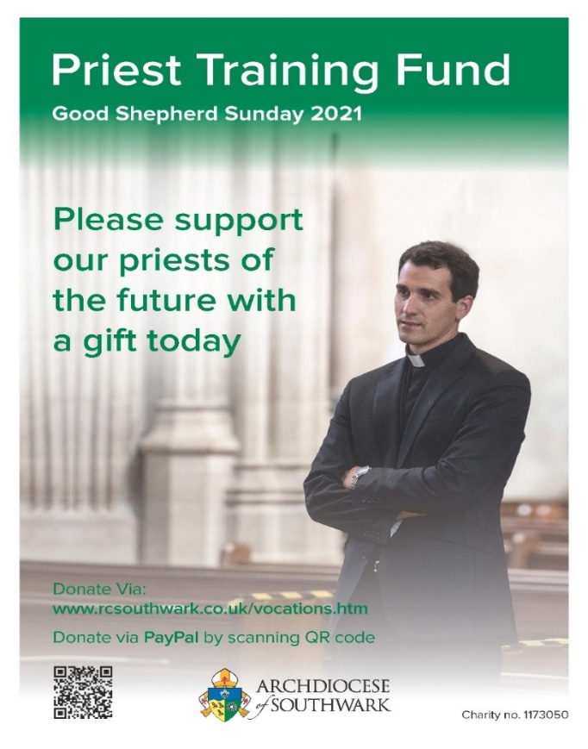**GOOD SHEPHERD SUNDAY**

Today we celebrate Good Shepherd, or Vocations, Sunday.

This is an important day to pray for vocations; encouragethose who may be considering consecrated life; donate **to Southwark's Priests' Training Fund,** so that the diocese can meet its obligations and offer both ecclesiastical education and formation to a man who wishes to become a priest or deacon.

Southwark's fundraising team have created a suite of materials to assist with promoting this special day.

It including a [poster](https://rcsouthwark.us11.list-manage.com/track/click?u=a40ab1a35eac7236d856fe882&id=5bdcb94522&e=7d4ac57aff), a [prayer card](https://rcsouthwark.us11.list-manage.com/track/click?u=a40ab1a35eac7236d856fe882&id=5ebb952cb0&e=7d4ac57aff) and an attractive [newsletter](https://rcsouthwark.us11.list-manage.com/track/click?u=a40ab1a35eac7236d856fe882&id=0fac7d6115&e=7d4ac57aff) which features Archbishop John, Fr Paul Kyne, our new Southwark vocations director, our newly ordained priests and the vocation stories of our current seminarians.

Southwark is also offering a website link for further reading on vocations and a place where online donations can made be at this website:

[http://www.rcsouthwark.co.uk/vocations.htm](https://rcsouthwark.us11.list-manage.com/track/click?u=a40ab1a35eac7236d856fe882&id=423a0f3f5e&e=7d4ac57aff)

**REMEMBER THE SICK AND NEEDY**

Please pray for all those in need at this time including: Vera De Souza, Mike Bond, Alice Barclay, Thelma Benn, Julie Ballesteros, Cora Litchfield, Sean Walsh, Judy Freegard, Imogen Fernando, Joan Charman, Joan Cunningham, Solveya La Marina, Chris Jones, Maria Reece, Margaret Bolton, Eddie Aldridge, Ellis Warburton, Mary Marks, Jean-Claude Anthony, Ellen Everett, Maureen Coffey, James Guckian, Elizabeth Sensano, Stephen Beck and sick residents at the four residential homes usually, in better times, visited by the parish St Vincent de Paul group.

|  |  |  |
| --- | --- | --- |
| **MASS INTENTIONS FOR THE WEEK** | | |
| Sat 24th | 6.30pm | Pro Populo |
| Sun 25th | 8.00am | Noreen Malone, RIP |
| Sun 25th | 10.00am | Albert Khayyat, wellbeing (SVP) |
| Sun 25th | 6.30am | Daniel Stas, wellbeing |
| Mon 26th | 10.00am | Patrick Coffey, RIP |
| Tues 27th | 10.00am | Intention of the Alvarez Family |
| Wed 28th | 10.00am | Intention of the Alvarez Family |
| Thurs 29th | 10,00an | Primo Tablizo, RIP |
| Fri 30th | 10.00am | Intention of the Alvarez Family |
| Sat 1st | 6.30pm | Mr Baladasan, RIP |
| Sun 1st | 8.00am | Pro Populo |
| Sun 1st | 10.00am | Giuseppe Sarracino, RIP |
| Sun 1st | 6.30pm | Mrs Margaret Walsh, RIP |

**WANT TO GO TO CONFESSION?**

Well you can – and at the same time be confident that you are safe from Covid. Simply give Fr Roy a ring and make an appointment. He will hear your confession in private in the hall.

***IF YOU TEST POSITIVE FOR COVID…***

Should that happen and you have been to Mass at St Columba’s in the preceding week, let Fr Roy or Deacon Philip know. For track’n’trace purposes, they may then need to contact anyone else who was at the same Mass.

**CONFIRMATION & FIRST COMMUNION**

Now that things are beginning to get back to some sort of normality, plans are being made for young people to receive the sacraments of initiation.

So parents of children age 7-8 should contact Fr Roy about the preparation course for First Holy Communion.

Young people (age 13-14) wishing to receive the Sacrament of Confirmation are advised to write a short letter to Fr Roy asking to be confirmed.



***SHOP ONLINE AND HELP ST C’S TOO***

Thinking of buying something online? Anything? A new washing machine or any other white goods?

Or perhaps you need a new vacuum cleaner or intend ordering a book or dvd or, in fact, other items.

If you do it online you can help St Columba’s finances, depleted by the lockdown, at the same time and at no cost to yourself.

More and more parishioners are signing up for this scheme. It means that you can turn your everyday online shopping into free donations to our parish.

It’s simple. It’s straightforward. And it will cost you nothing.

All you have to do is to logon to the following website [www.easyfundraising.org.uk](http://www.easyfundraising.org.uk), register (which is quick and easy) and then go shopping online at whichever retailer you choose. Each time you buy something – anything – a small donation is made to St Columba’s.

|  |  |  |
| --- | --- | --- |
| There are more than 4,000 retailers to choose from including lots of big names such as Argos, John Lewis, Amazon, M&S and Sainsbury’s.  Have a look at this link to find out more: [https://www.easyfundraising.org.uk/causes/stcolumbasldn/?invite=ZTUSO0%26referral-campaign=c2s%26utm_campaign=admin-trigger%26utm_content=nst](http://t.e.easyfundraising.org.uk/r/?id=h2ef6bab4,257a256b,25302fff&utm_source=adobecampaign&utm_medium=email&utm_campaign=referral-2018&utm_content=trigger-supp-referee-raised-2018&origin=RTNS2&p1=stcolumbasldn&p2=ZTUSO0)  **WHAT DO YOU THINK OF IT SO FAR…?**  **Our newsletter, that is.**  **Your comments, thoughts, suggestions, ideas and contributions would be most welcome.**  **They will also enable us to know whether this newsletter is considered helpful and useful – or not. Email Deacon Philip – the deadline for each weekend’s newsletter is the Wednesday before.** |  |  |

**GOT YOUR GIFT AID ENVELOPES?**

**All members of the Gift Aid scheme are invited this weekend to collect their boxes of envelopes for the coming year.**

**The boxes, with your names on, can be collected at the entrance to the sacristy in the Sacred Heart chapel after all Masses.**

**THINK YOU HAVE A VOCATION?**

The Beda College in Rome is running a discernment weekend for men between the ages of 30 and 55 from September 3-5. It takes place at St Beuno’s Spirituality Centre in North Wales.

The weekend is a first step for those who may be exploring the possibility of priestly vocation in later life.

Information and registration forms are at: <https://www.pathwaystogod.org/courses-events-retreats/discernment-weekend-older-men-1>

**HOW DID COVID AFFECT YOU?**

Our diocesanAgency for Evangelisation and Catechesis has partnered with other dioceses to produce and promote a survey which aims to find out about the experiences of Catholics over the period of the Coronavirus pandemic.

This research will help us to understand what has been happening during this time when churches have been closed and/or only opened for limited periods and Catholics have had to practice their faith ‘at a distance’. To complete the survey, select our Archdiocese from the drop-down menu so that we can hear about what God has been doing and what He wants to say to us about the future of the Church in this part of England and Wales.

This important survey should take about 10 minutes to complete and the deadline for submissions for Southwark is July 4. Click on this link:

<https://forms.rcaos.org.uk/covid-19-survey-form/>

**ANNUAL MIGRANTS’ MASS**

In the Year of St Joseph and in honour of St Joseph the Worker, the London dioceses of Southwark, Westminster and Brentwood will celebrate the 16th annual Mass for migrants on Saturday May 1 at 11.20am.

This year the Mass will be celebrated by Bishop Paul McAleenan and live-streamed from St William of York Roman Catholic church, Forest Hill.

Although people cannot attend in person, this lively online service will still celebrate the significant contribution made by migrants to the life of our dioceses. All are welcome. For more details visit:

[https://actionnetwork.org/events/migrants-mas](https://rcsouthwark.us11.list-manage.com/track/click?u=a40ab1a35eac7236d856fe882&id=0c4e55488e&e=7d4ac57aff)s

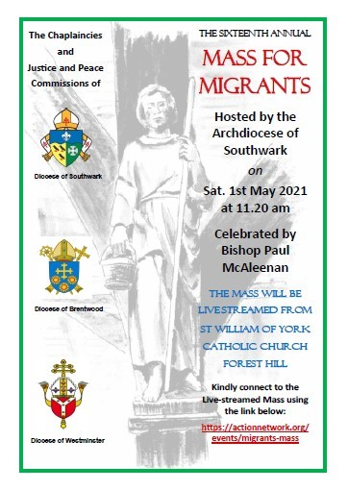

**VICTIMS & SURVIVORS OF ABUSE**

**Make a note in your diary. There will be a day of prayer for victims and survivors of abuse on May 4.**

**Details and resources can be found on the website:**

<https://www.cbcew.org.uk/day-of-prayer-abuse-survivors-2021/>

***KEEPING ST COLUMBA’S OPEN DURING THE PANDEMIC***

**We have a number of parishioners who have been doing an invaluable job during the pandemic to ensure that St Columba’s can stay open for Mass, every Mass.**

**You may not have noticed them, quietly going about their job. But that job is essential.**

**Volunteers all, they are the stewards who check people into the church before Mass starts, ensure they provide a completed track’n’trace form, hand out face masks if needed and make sure everyone uses hand sanitizer. After Mass they clean the seating which has been used and sanitize door handles and the like.**

**These volunteers are essential if we are to keep St Columba’s open during the pandemic.**

**But there are not enough of them: we need more, especially now that the benches are back in use and numbers attending Mass hopefully will start to increase.**

**If you are willing to help - and do give it serious consideration - contact Fr Roy or Deacon Philip.**

**KNOW OF ANYONE IN NEED?**

Are you aware of any parishioners living alone or in need?

If so, as well as phoning them yourself occasionally to see if they need anything, let Fr Roy or Deacon Philip know of their whereabouts.

That way, we can work together to support and help them at this difficult time.

**LIFE IN THE SPIRIT SEMINARS**

**Make a note of the dates of Tuesdays between May 4 and June 1.**

The Agency for Evangelisation and Catechesis and the Southwark Archdiocese Catholic Charismatic Team will then be offering a wonderful opportunity for personal and diocesan renewal.

Through a series of the Life in the Spirit seminars you will be invited to grow in your love of the Lord, welcome the Spirit into your life afresh and pray for the renewal of our diocese.   
Each Tuesday evening the seminars will feature a talk from a gifted speaker and small group sharing.  
On Saturday 22 May, in addition to the Tuesday evenings, the series will feature a double-bill of seminars (a separate link will be emailed to all registrants for this special day).  
If you would like to know more or to sign up please [Register here](https://rcsouthwark.us11.list-manage.com/track/click?u=a40ab1a35eac7236d856fe882&id=786fdce19c&e=7d4ac57aff)

**ST JOSEPH’S 150TH ANNIVERSARY**

In preparation for the 150th anniversary of the opening of St Joseph’s School, Upper Norwood, former pupils, parents, staff, governors and friends are invited to submit recollections, photos and memorabilia.

They will be displayed in anniversary publications and at events. Please include a description of any items sent, name people in photos and add a date or occasion when the photograph might have been taken.

During the celebratory year, beginning in September, there will be many opportunities to visit St Joseph’s and to meet with other Alumni to mark this special milestone. Please help spread the news to all those associated with St Joseph’s.

To share memories of your days at St Joseph’s, or to receive more information as the plans for the anniversary year unfold, please email your contact details to: [alumni@st-josephs-jun.croydon.sch.uk](mailto:alumni@st-josephs-jun.croydon.sch.uk)

For more details visit the school’s website: <https://www.stjosephsfederation.co.uk/>

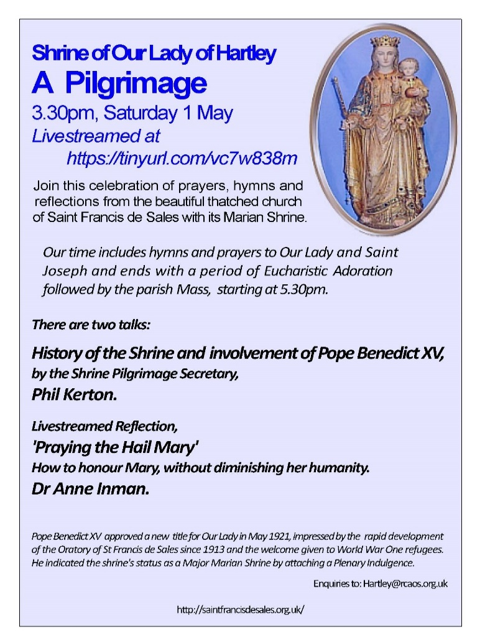

**MARIAN SHRINE PILGRIMAGE**

Join the parish of St Francis de Sales at its Marian Shrine in Hartley for their online pilgrimage on Saturday 1st May at 3.30pm.  The parish will be offering hymns, prayers and reflections.

**GOING INTO HOSPITAL? TELL US**

If you or a member of your family go into hospital, ask the Ward Sister or Staff Nurse to notify the hospital’s Roman Catholic hospital chaplain direct.

That will make it much more likely that you have the opportunity of receiving Holy Communion (or any other sacraments) while in hospital. And don’t forget to let Fr Roy or Deacon Philip know beforehand of your admission into hospital. We can then keep you in our prayers.

**CHURCHES TOGETHER & THE CLIMATE**

This is an important year for churches to act together to protect God's creation and for us, as Christians, to have a positive impact on the global emergency.

With the UK hosting both the G7 in June and the UN COP26 in November, this is an opportunity for our leaders to champion and exemplify key actions to achieve climate justice.

A webinar will take place at 7pm on May 6 to mark all of this.

Join speakers Luke Harman of Christian Aid, talking about the importance of climate finance, Beth Naylor-Smith of Young Christian Climate Network, reflecting on the the relay from the G7 in Cornwall to COP26 in Glasgow (which will pass through London between August 5-8)), and Rosh Lal of Faith, talking about the Climate about movement building and the COP Faith Task Group.

Tangible actions and usable resources will be shared to empower participants to make a difference in changing the climate trajectory and support our neighbours around the world.

Contact [claire@ctslondon.org.uk](mailto:claire@ctslondon.org.uk) and a Zoom link will be distributed nearer the date.   
Please do invite guests who would be interested in joining this event, especially young people.

**LAUDATO SI’ WEEK**

|  |
| --- |
| Laudato Si’ Week, to be held between May 16-24 and the Global Catholic Climate Movement will be holding a series of special events to mark the Laudato Si’ anniversary year.  This will be a celebration of the progress the whole Church has made on its journey to ecological conversion. The week will include prayer gatherings, music, discussions about energy and fossil fuels, and a presentation on the Care of Creation. View the full programme and register interest here: [LaudatoSiWeek.org](https://rcsouthwark.us11.list-manage.com/track/click?u=a40ab1a35eac7236d856fe882&id=ab22cf3180&e=7d4ac57aff) |

**BEYOND THE CROSS**

'Beyond the Cross'is a five-part art and culture series produced by the Catholic Bishops' Conference of England and Wales.  It follows on from 'At the Foot of the Cross', which considered four famous paintings telling the story of Christ's Passion and Resurrection. 'Beyond the Cross' follows the Risen Christ through the artist's eye taking in some of the main encounters of the season of Easter.

In the video (see below) the viewer is asked to look at the empty tomb and take as inspiration the Swiss painter Eugene Burnand's 1898 work 'The Disciples Peter and John Running to the Sepulchre on the Morning of the Resurrection'.

[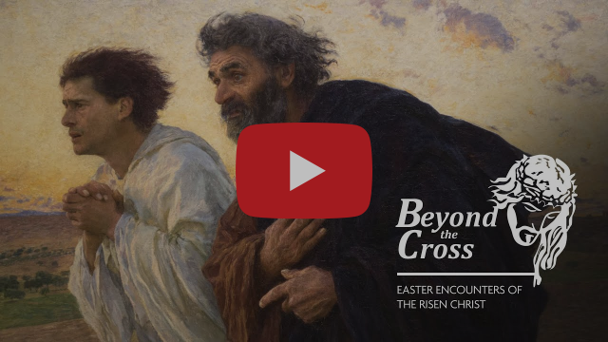](https://rcsouthwark.us11.list-manage.com/track/click?u=a40ab1a35eac7236d856fe882&id=82506f85a7&e=7d4ac57aff)

**FIGHTING RACISM**

Following the official inauguration of the Racial Justice Commission (RJC) in January by Abp John Wilson, the RJC wish to reach out to every community in this archdiocese to help seek to identify, address and speak out against the evil of racism where it exists.

They wish to raise awareness of the responsibility of everyone to eradicate racial discrimination in all its forms within the Church and wider society.

Their goal is to work with parishes, different groups and schools to make this a reality.

In the words of the Catholic bishops of Southwark, “Racism is incompatible with the Catholic Faith. Whether expressed by the attitudes or behaviour of an individual, or the behaviour of a group, or through unjust structures in society that exclude and discriminate, there is no place for racism at any time or in any place. We say this again: there is no place for racism.”

“We cannot tolerate or turn a blind eye to racism and exclusion in any form and yet claim to defend the sacredness of human like” – *Pope Francis*.

Racism is not a political issue but a human right issue. It is a human right pandemic and this is the time to act.

The Commission for Promoting Racial and Cultural Inclusion, to give the RJC’s full name, facilitates engagement with marginalised communities and promotes opportunities for a growth in understanding in matters of diversity and inclusion and explore ways to listen, accompany and support victims of racism, with a view to eliminating this infringement on human dignity.

Over the coming months, you will be invited to support the work of the commission in fighting this sinful practice and violation of human dignity.

Let us all come together and make this a reality.

Visit <https://racialjustice.rcaos.org.uk/> for more details of the RJC.

**EASTER IMAGES**

St George's Cathedral were fortunate to have the Bishops' Conference photographer, Marcin Mazur, present during Holy Week.

For those that wish to view some beautiful professional images of the Easter services with Archbishop John at St George's Cathedral, visit the [CBCEW Flickr site:](https://rcsouthwark.us11.list-manage.com/track/click?u=a40ab1a35eac7236d856fe882&id=ef78db542f&e=7d4ac57aff)

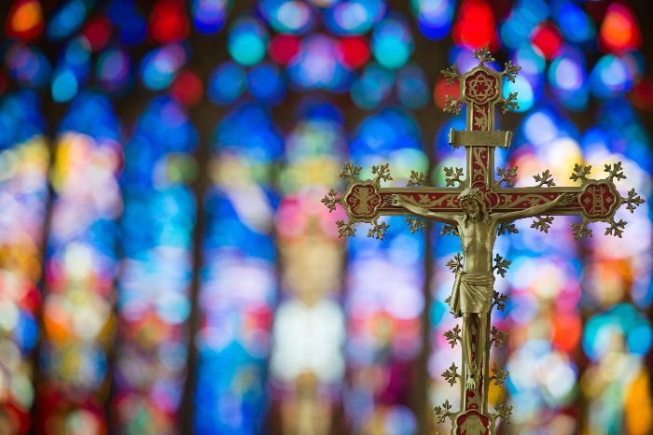

**OFFERTORY COLLECTION**

**The Offertory collection of April 11 totalled £374.40 of which £218 was Gift Aided and £156.40 not.**

**The collection of April 18 totalled £380.81 of which £224 was Gift Aided and £156.81 not.**

**A further £15 was donated towards the Easter offering (Gift Aided).**

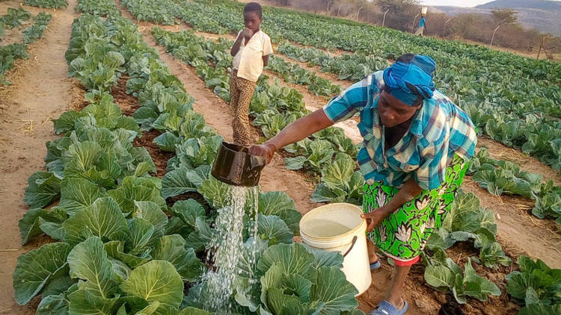

**THIS IS WHAT RESULTED…**

Thank you for your generous donations to CAFOD’s Family Fast Day during Lent.

The project featured Marian and her son Svondo (pictured above) in Zimbabwe in Lent 2018.

The community vegetable garden that your donations helped provide is growing well and during the pandemic the family has survived on the vegetables.

Your support has also helped to provide soap and handwashing stations in the garden and in family homes.

This is just one of many long-term development projects that CAFOD has funded with the money from that Fast Day.

**MARY’S MEALS: 1.8M BENEFIT**

Since its humble beginnings, Mary’s Meals, named after Mary the Mother of Jesus, has been built on a foundation of prayer and the many little acts of love from those who support it.

During May, the month traditionally dedicated to Our Lady, you are invited to join in prayer to celebrate the wonderful work of Mary’s Meals.

Give thanks that more than 1.8 million children in 19 countries are receiving a nutritious meal every school day as a result.

Inspirational resources for the Pray In May campaign, including a prayer card, can be found on [our website](https://marysmeals.us18.list-manage.com/track/click?u=71642ed3d70deb2b1c25da8f0&id=1c30715a38&e=ef965371e1).