**St Columba’s Church, Selsdon**

37 Queenhill Road, Selsdon, South Croydon, CR2 8DW

Parish telephone number: 020 8657 3747

Parish Priest: Father Roy Tablizo

E: [selsdon@rcaos.org.uk](mailto:selsdon@rcaos.org.uk)

Deacon: Rev. Philip Pond E: [philippond@rcaos.org.uk](mailto:philippond@rcaos.org.uk)

T: 07764 845 890

Parish website: [www.stcolumbaschurchselsdon.uk](http://www.stcolumbaschurchselsdon.uk)

**28 MARCH 2021**

**PALMSUNDAY OF THE PASSION OF THE LORD (YEAR B)**

**THIS SUNDAY’S MASS READINGS**

**Entrance Antiphon:** Six days before the Passover, when the Lord came into the city of Jerusalem, the children ran to meet him; in their hands they carried palm branches and with a loud voice cried out:

Hosanna in the highest! Blessed are you, who have come in your abundant mercy! O gates, lift high your heads; grow higher, ancient doors. Let him enter, the king of glory! Who is this king of glory? He, the Lord of hosts, he is the king of glory. Hosanna in the highest! Blessed are you, who have come in your abundant mercy!

**A reading from the prophet Isaiah: 50:4-7**

**Responsorial Psalm PS 21:8-9. 17-20. 23-24. Rv.2:** My God, my God, why have you forsaken me?

**2nd Reading: from the letter of St Paul to the Philippians: 2:6-11**

**Gospel Acclamation:** Praise to you, O Christ, king of eternal glory: Christ was humbler yet, even to accepting death, death on a cross. But God raised him high and gave him the name which is above all names. Praise to you, O Christ, king of eternal glory.

**Gospel: The passion of our Lord Jesus Christ according to Mark: 15:1-39**

**Communion Antiphon:** Father, if this chalice cannot pass without my drinking it, your will be done.

**WANT TO GO TO CONFESSION?**

Well you can – and at the same time be confident that you are safe from Covid.

Fr Roy will be hearing Confessions after 10am Mass on Monday and Tuesday, also from 10-11am on Maundy Thursday and Good Friday. For other times simply give him a ring and make an appointment.

***How To Recognise the Ultimate Goal of Life***

Fr Roy reflects on the readings for Palm Sunday

As we enter Holy Week, we are encouraged to sit back and reflect on the central mysteries of the Catholic faith, namely the passion, death and resurrection of Jesus Christ.

Recent developments around the world have forcibly brought home to us the fragility of life.

One important lesson of this is that we cannot leave our spiritual destiny to fate.

But we can be confident about building a relationship with God and therefore our salvation.

We must trust God because he is the only one capable of assuring us of the certainty of heavenly life.

Covid-19 has dramatically brought home to us all the limitations of our earthly life.

As a result we are a lot wiser in that respect now than before the pandemic struck.

Wisdom tells us that heaven is the ultimate goal of life.

Recognising that earthly passions are bound to lead us astray, that realisation should help us focus our attention more on heavenly things.

Too often we use our weaknesses as an excuse for sinfulness.

But sacrificing earthly passions is essential if we want to complete our journey to heaven.

In effect we are challenged to curb our errant passions in order to follow in the footsteps of Jesus. Controlling those passions is the key to genuine discipleship.

Just consider. Jesus spent 40 days in the desert preparing himself for his earthly ministry in order to encourage us recognise that we can indeed triumph over our earthly desires.

His death on the cross provides the single greatest example of the fact that death to selfishness is crucial to our salvation.

Jesus assures us that because we have the help of the Holy Spirit no amount of temptation can overpower us.

Holy Week provides us with the opportunity to review and change our approach; to get rid of all our excuses and instead to focus on building a healthy relationship with God.

In other words, our commitment to our faith should translate into making Jesus Christ live in our individual lives.

Temptation is meant to be overcome by the discipline we have practised during the Lenten season.

So what better time could there be to renew our commitment to Jesus’s call than the celebration of the paschal triduum at the end of Lent.

The benefits of that discipline empower us to view life from God’s perspective.

As a result we are better able to view the world through God’s eyes; the only meritorious way of living. We have all come to a realisation during the pandemic that we can never trust worldly values because they do not guarantee heavenly life.

The choices we make as a result reflect the reality of our allegiance; whether we belong to this world or have chosen to be allied with God.

One thing is certain: we can never enjoy both worlds for they are completely irreconcilable.

The truth is that having experienced the wisdom of God, we have every reason and incentive to follow Jesus’s example.

We don’t need an explanation of this because God reveals to us the significance of our faith.

All that remains is for us is to commit to the message and allow the good news to direct us towards God’s kingdom.

This is the path that countless saints have followed with full confidence in God’s grace and salvation. We need to do the same.

**STATIONS OF THE CROSS ONLINE AT 7PM EVERY FRIDAY EVENING**

Don’t forget. On Friday evening there are Stations of the Cross online every week during Lent from St Columba’s.

They can be accessed at 7pm every Friday via YouTube using the same link as for daily Mass:

<https://www.youtube.com/channel/UCYVyZ2Xpfs0NiuU3bxAjsCQ/live>

All are welcome. Note: the church will not be open.

**NOW WE HAVE THE BENCHES BACK**

Yes, the chairs (or most of them) have now gone and you can once again sit/kneel in the benches.

People must, however, make sure to leave plenty of space between them in the bench. There should be no more than three people – unless you are a family or in a bubble. The ideal is one person at each end and one in the middle.

When you leave your bench at the end of Mass, make sure to lower the kneeler. That’s so that it’s obvious which benches need cleaning.

Do please be prepared to lend a hand helping the stewards clean the benches, including the handrails, after Mass.

Don’t forget that the one-way system is still in force: come into the church via the Sacred Heart chapel/confessional and leave via the main door at the back.

***DON’T FORGET WHEN COMING TO ST COLUMBA’S…***

We know we must take precautions when coming to Mass. They are set by the Government – and the local council is checking that we comply. So make sure to:

* Remember to bring and wear a face mask covering the nose as well as the mouth
* Enter the church via the side door leading into the Sacred Heart chapel/confessional, observe the one-way system and leave via the centre back door.
* Meet Track-and-Trace requirements by providing a written note – and this applies every time you come to church – of your name and contact details (phone number or email or postal address) plus the date and, if relevant, Mass time. To save queuing and filling out a form, send an email to selsdon@rcaos.org.uk
* Use hand sanitizer, provided, both when entering and leaving the church.
* Unless they are in your family or bubble, leave plenty of space between yourself and anyone else in your bench – there should be no more than three people in a bench.
* Leave where they are the chairs which have replaced some of our benches and are at 1m intervals to ensure the necessary social distancing.
* Bring your own Mass or prayer book – there are no shared items:. That applies to readers as well.
* Keep silent when receiving Holy Communion.
* If you are sitting on a chair as opposed to being in a bench, before leaving the church, turn your chair back to front so that the stewards know which ones to clean afterwards. That also includes any chair you may have used, for example the one in front as support when kneeling during Mass.
* Leave the church straight after Holy Communion and don’t congregate outside to socialise.

|  |  |
| --- | --- |
| **LITURGICAL CALENDAR OF THE WEEK** | |
| Sat 27th | Weekday of Lent |
| Sun 28th | Palm Sunday of the Passion of the Lord |
| Mon 29th | Monday of Holy Week |
| Tues 30th | Tuesday of Holy Week |
| Wed 31st | Wednesday of Holy Week |
| Thurs 1st | Maundy Thursday |
| Fri 2nd | Good Friday |
| Sat 3rd | Holy Saturday |
| Sun 4th | Easter Sunday |

**DON’T REFUSE A COVID JAB**

**A series of films has been produced by the NHS to encourage and promote the uptake of Covid-19 vaccination across Black, Asian and minority ethnic communities as well as different faith groups. Presenters include a permanent deacon from St Joseph’s, Bromley.**

**You can watch by clicking any of the links here:**

* YouTube: <https://www.youtube.com/playlist?list=PL1fo7mb0qmAvQANj-ByeV72ScnslGPk2M>
* Facebook: <https://fb.watch/3oZtBYzOUd/>
* Twitter: <https://twitter.com/NHSSELondonCCG/status/1356571921983426564>

|  |  |  |
| --- | --- | --- |
| **MASS INTENTIONS FOR THE WEEK** | | |
| Sat 27th | 6.30pm | Pro Populo |
| Sun 28th | 8.00am | David Chan Sing, RIP, Jeanie & Winston, wellbeing |
| Sun 28th | 10.00am | Bruno Sampson, RIP |
| Sun 28th | 6.30pm | Mrs Joseph, RIP |
| Mon 29th | 10.00am | For the Family of Maria Salve Gianan, RIP |
| Tues 30th | 10.00am | Thanksgiving for Parishioners’ prayers for Judy Freegard |
| Wed 31st | 10.00am | In Thanksgiving |
| Thurs 1st h | 8.00pm | Maundy Thursday Pro Populo |
| Fri 2nd | 3.00pm | Good Friday Service with Holy Communion |
| Sat 3rd | 8.30pm | Pro Populo |
| Sun 4th | 8.00am | Loretta Sean, Deni & Family, wellbeing |
| Sun 4th | 10.00am | Elizabeth Harris, RIP |

**KNOW OF ANYONE IN NEED?**

Are you aware of any parishioners living alone or in need?

If so, as well as phoning them yourself occasionally to see if they need anything, let Fr Roy or Deacon Philip know of their whereabouts.

That way, we can work together to support and help them at this difficult time.

**REMEMBER THE SICK AND NEEDY**

Please pray for all those in need at this time including: Kevin Staunton, Alice Barclay, Thelma Benn, Julie Ballesteros, Cora Litchfield, Sean Walsh, Judy Freegard, Imogen Fernando, Joan Charman, Joan Cunningham, Solveya La Marina, Chris Jones, Maria Reece, Margaret Bolton, Eddie Aldridge, Ellis Warburton, Mary Marks, Jean-Claude Anthony, Ellen Everett, Maureen Coffey, James Guckian, Elizabeth Sensano, Stephen Beck and sick residents at the four residential homes usually, in better times, visited by the parish St Vincent de Paul group.

**PARISH COUNCIL MEETS TO CONSIDER THE FUTURE**

For the first time after a gap of more than a year, because of Covid, St Columba’s parish council met this week – online, courtesy Zoom.

Some 21 people logged on to discuss and consider the best way forward for our parish after the disruption caused by the pandemic.

The primary focus was how to rebuild St Columba’s as a family once the main lockdown restrictions have been relaxed by the Government.

Various initiatives were suggested and discussed and there was agreement among parishioners about the way forward.

However, it was also agreed that until restrictions are relaxed as set out in the Government’s roadmap to recovery, major changes would be unwise as well as possibly being against the regulations.

However, we are as of now planning and preparing for the end of lockdown which will probably be on June 21.

Nonetheless there will be changes and improvements before then.

For example, the benches have already been returned to the church, albeit with limits on the number of people who can use them.

That will usually be a maximum of three, one at each end and one in the middle unless it’s a family or members of a bubble.

With these changes, up to 100 people can now be seated for Mass.

In order to help the stewards when cleaning benches after each service, parishioners are asked to leave the kneelers down so that it is obvious which have been used.

Where the kneeler is fixed, the people using that bench are asked themselves to take responsibility for cleaning the handrail as well as the seat itself. (There are cleaner sprays and hand towels both at the entrance to and exit from the church – help yourself.)

Hopefully starting soon there will be music and singing – though not by the congregation – at 10am Sunday Mass, a mixture of solos by invited guest singers and pre-recorded hymns.

Those wishing to receive the Sacrament of Reconciliation can do so now – if you wish to go to Confession, contact Fr Roy for an appointment.

Other initiatives planned for the end of lockdown (dates to be confirmed) include:

* A welcome-back newsletter with an invitation to return from our parish priest, Fr Roy, posted through all parishioners’ letterboxes the week before the church fully reopens.
* Café St Columba to reopen for morning coffee (and home-made cakes) and light lunches on one Wednesday a month.
* Coffee mornings after Sunday 10am Mass.
* Preparation for and celebration of First Communions - the date to be announced (all interested parents should contact Fr Roy without delay).
* The Sacrament of Confirmation – youngsters aged 13 or 14 wishing to be confirmed are invited to get in touch with Fr Roy now about a course of preparation.
* Uniformed groups – Rainbows and Brownies have continued to meet during lockdown, having fun’n’games on Zoom. The Guides are planning a programme of events. (More details from Yvonne Barnard overleaf.)

Other initiatives as well as a choice of social events are being planned and will be announced in due course. Watch this space…

The final message from the parish council meeting was simple. As we look forward to the end of lockdown, in order to keep everyone safe and well we must all continue to observe all the precautions that have been in force over past months. You can see those in detail overleaf.

**GOING INTO HOSPITAL? TELL US**

If you or a member of your family go into hospital, ask the Ward Sister or Staff Nurse to notify the hospital’s Roman Catholic hospital chaplain direct.

That will make it much more likely that you have the opportunity of receiving Holy Communion (or any other sacraments) while in hospital. And don’t forget to let Fr Roy or Deacon Philip know beforehand of your admission into hospital. We can then keep you in our prayers.

**RAINBOWS, BROWNIES & GUIDES**

During the pandemic, Rainbows and Brownies have been using Zoom to meet online. The girls have enjoyed planned activities in their own homes and are hoping to meet outdoors and face to face after Easter.

The numbers have maintained and even grown, which is incredible at this moment in time. It shows that organisations like this are where parents are looking to help their children have access to activities and see their friends, be it currently only online.

The Guides have taken a break from meeting during the lockdown,but as it eases they will start to come together again, outdoors, from the March 29. We are following the Girlguiding and the Government guidelines and have been advised that meetings indoors can begin again after the summer break in September.

If your daughter would like to learn more about the exciting and interesting activities that take place in Rainbows, Brownies or Guides, then please feel free to contact Yvonne Barnard (07765 104307). She would be delighted to share her many years of experience and advise how your daughter can be registered to join the world of Girlguiding.

***IF YOU TEST POSITIVE FOR COVID…***

Should that happen and you have been to Mass at St Columba’s in the preceding week, let Fr Roy or Deacon Philip know.

For track’n’trace purposes, they may then need to contact anyone else who was at the same Mass.

**VOICES FROM THE HOLY LAND**

During Lent last year, Fr Richard Nesbitt found inspiration to write a series of 15 poems on the themes of Our Lord’s passion, death and resurrection as he faced the challenge of a closed church at Easter,

Through the Friends of the Holy Land charity, a number of people in the Holy Land were then approached to offer their reflections on the Scriptures for Holy Week, the poems and their own personal experiences.

The result is **Holy Week Voices from the Holy Land**, a prayerful and timely resource, which contains:

* Forewords by Cardinal Vincent Nichols and Archbishop Justin Welby of Canterbury
* 15 chapters each featuring a poem, Scripture, a reflection from a Holy Land
* ‘Voice’, a prayer and questions for meditation.
* Stations of the Cross during a Time of Pandemic, first prayed at Our Lady of Fátima in Lent 2020.
* An invitation to share the reader’s own poem or reflection on Simon of Cyrene.

Holy Week Voices from the Holy Land can be used for individual meditation. Parishioners may wish to purchase a physical copy directly from Friends of the Holy Land or obtain an electronic/digital version (also priced £7.99): click on:

[(](https://rcsouthwark.us11.list-manage.com/track/click?u=a40ab1a35eac7236d856fe882&id=206196bab0&e=7d4ac57aff)[www.friendsoftheholyland.org.uk](https://rcsouthwark.us11.list-manage.com/track/click?u=a40ab1a35eac7236d856fe882&id=6262e7e53a&e=7d4ac57aff)[)](https://rcsouthwark.us11.list-manage.com/track/click?u=a40ab1a35eac7236d856fe882&id=2cce6fb326&e=7d4ac57aff).

The proceeds will go towards their work in helping our Christian brothers and sisters in that area, who have suffered a dramatic loss of livelihood due to the significant decline in pilgrimages to Bethlehem and the surrounding areas.



***SHOP ONLINE AND HELP ST C’S TOO***

Thinking of buying something online? Anything? A new washing machine or any other white goods?

Or perhaps you need a new vacuum cleaner or intend ordering a book or dvd

or, in fact, other items.

If you do it online you can help St Columba’s finances, depleted by the lockdown, at the same time and at no cost to yourself.

More and more parishioners are signing up for this scheme. It means that you can turn your everyday online shopping into free donations to our parish.

It’s simple. It’s straightforward. And it will cost you nothing.

All you have to do is to logon to the following website [www.easyfundraising.org.uk](http://www.easyfundraising.org.uk), register (which is quick and easy) and then go shopping online at whichever retailer you choose. Each time you buy something – anything – a small donation is made to St Columba’s.

|  |  |  |
| --- | --- | --- |
| There are more than 4,000 retailers to choose from including lots of big names such as Argos, John Lewis, Amazon, M&S and Sainsbury’s.  Have a look at this link to find out more: [https://www.easyfundraising.org.uk/causes/stcolumbasldn/?invite=ZTUSO0%26referral-campaign=c2s%26utm_campaign=admin-trigger%26utm_content=nst](http://t.e.easyfundraising.org.uk/r/?id=h2ef6bab4,257a256b,25302fff&utm_source=adobecampaign&utm_medium=email&utm_campaign=referral-2018&utm_content=trigger-supp-referee-raised-2018&origin=RTNS2&p1=stcolumbasldn&p2=ZTUSO0)  **WHAT DO YOU THINK OF IT SO FAR…?**  **Our newsletter, that is.**  **Your comments, thoughts, suggestions, ideas and contributions would be most welcome.**  **They will also enable us to know whether this newsletter is considered helpful and useful – or not. Email Deacon Philip – the deadline for each weekend’s newsletter is the Wednesday before.**  **KNOWING JESUS: AN ONLINE RETREAT**  Walk with the Jesuits through Lent and Easter and really come to understand and love Jesus. This online retreat, pondering Gospel stories, will reflect on their meaning and see how startlingly relevant Jesus is to living a truly human life in the 21st Century. Sign up by clicking here:  <https://www.onlineprayer.net/> You can also sign up to receive daily emails during Lent and additional resources: [http://eepurl.com/hnIXAn](https://rcsouthwark.us11.list-manage.com/track/click?u=a40ab1a35eac7236d856fe882&id=3bb43464bf&e=087693309e) |  |  |

**FAITH COMPANION: TASTE AND SEE**

The *Faith Companion* is an online magazine likely to be of interest to parishioners and recommended by our own Abp John.

Visit its website and you will also find details of Christian Gifts online including the *Faith Companion* candle, rosaries, journals and a skin care range made by Benedictine monks.

A free copy of the magazine is obtainable to “taste and see” by visiting the website at <http://www.thefaithcompanion.co.uk>. Please do consider supporting their work for the Church.

**COLLECT YOUR GIFT AID ENVELOPES**

**All members of the Gift Aid scheme are invited this weekend to collect their boxes of envelopes for the coming year.**

**The boxes, with your names on, can be collected at the entrance to the sacristy in the Sacred Heart chapel after all Masses.**

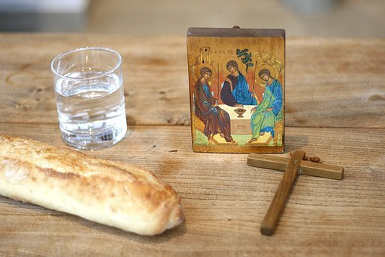

**LENT: HOW ARE YOU GETTING ON?**

**How are you getting on with your Lenten resolutions?**

**Whatever you have chosen to do or not to do, you could do worse than simply remember and try to put into practice the little list of things to give up (fast from) suggested by Pope Francis.**

**Here they are:**

**Give up hurtful words and say kind words instead.**

**Give up sadness and be filled with gratitude.**

**Give up aggression and be patient.**

**Give up worrying and trust in God.**

**Give up complaining and contemplate simplicity.**

**Give up stress and be prayerful.**

**Give up bitterness and be joyful.**

**Give up selfishness and be compassionate.**

**Give up grudges and be reconciled.**

**Give up words and listen to God.**

**THANK YOU FOR YOUR OFFERING**

**The Offertory collection on March 14 totalled £685.10 of which £425 was gift aided and £260.10 not. That on March 21 totalled £288.73 of which £112.90 was gift aided and £175.83 not.**

**Many thanks everyone.**

**THINK YOU HAVE A VOCATION?**

The Beda College in Rome is running a discernment weekend for men between the ages of 30 and 55 from September 3-5. It takes place at St Beuno’s Spirituality Centre in North Wales.

The weekend is a first step for those who may be exploring the possibility of priestly vocation in later life.

Information and registration forms are at: <https://www.pathwaystogod.org/courses-events-retreats/discernment-weekend-older-men-1>

**HOW DID COVID AFFECT YOU?**

Our diocesanAgency for Evangelisation and Catechesis has partnered with other dioceses to produce and promote a survey which aims to find out about the experiences of Catholics over the period of the Coronavirus pandemic.

This research will help us to understand what has been happening during this time when churches have been closed and/or only opened for limited periods and Catholics have had to practice their faith ‘at a distance’. To complete the survey, select our Archdiocese from the drop-down menu so that we can hear about what God has been doing and what He wants to say to us about the future of the Church in this part of England and Wales.

This important survey should take about 10 minutes to complete and the deadline for submissions for Southwark is July 4. Click on this link:

<https://forms.rcaos.org.uk/covid-19-survey-form/>

**VICTIMS & SURVIVORS OF ABUSE**

**Make a note in your diary. There will be a day of prayer for victims and survivors of abuse on May 4. More details to follow nearer the time.**

**EASTER SERVICES WITH ABP JOHN**

Various services celebrated by our Archbishop John Wilson are going to be livestreamed from the Cathedral:

Palm Sunday 28 March: 12 noon, solemn Mass

Holy Wednesday 31 March:  11:30 Chrism Mass

Maundy Thursday 1 April: 19:30 Mass

Good Friday 2 April: 15:00 the Passion of the Lord

Holy Saturday 3 April: 20:30 Paschal Vigil

Easter Sunday 4 April: 10:00 Family Mass

**For more details visit the Southwark diocesan website:** <http://www.rcsouthwark.co.uk/>

**KEEPING ST COLUMBA’S OPEN DURING THE PANDEMIC**

**We have a number of parishioners who have been doing an invaluable job during the pandemic to ensure that St Columba’s can stay open for Mass.**

**They are the stewards who check people into the church before Mass starts, ensure they provide a completed track’n’trace form and make sure everyone uses hand sanitizer. After Mass they clean the seating which has been used and sanitize door handles and the like.**

**These volunteers are essential if we are to keep St Columba’s open during the pandemic.**

**But there are not enough of them: we need more, especially now that the benches are back in use and numbers attending Mass hopefully will start to increase.**

**If you are willing to help - and do give it serious consideration - contact Fr Roy or Deacon Philip.**

**DOUBLE YOUR MONEY BY HELPING THE HOMELESS**

The Passage’s mission and work are developing to cope with more people becoming homeless.

Currently it is raising funds through the Big Give – which runs until Wednesday (March 31) – to support No Night Out, a new initiative to take newly homeless people off the street straight away.

Visit the website: [www.passage.org.uk](http://www.passage.org.uk) for more details.

Double your donation, double your impact: this is a matched giving scheme for online donations.

If someone (it can be a company, individual or trust) gave £10, the scheme would bring the gift up to £20. With gift aid that goes up to £22.50 for an individual.

For someone on higher rate tax it could cost the donor less than £10.

For more information ring 020 75921886 or email [andrew.h@passage.org.uk](mailto:andrew.h@passage.org.uk)

You can donate at <https://tinyurl.com/NoNightOut>



**OUR EASTER SERVICE TIMES**

Maundy Thursday (April 1): 8pm Mass of the Lord’s Supper

Good Friday: 3pm The Passion of the Lord

7pm Online Stations of the Cross

Holy Saturday: 8.30pm The Easter Vigil

Easter Sunday: 8am Mass

10am Mass

***Note that there will be no Mass Easter Sunday evening.***

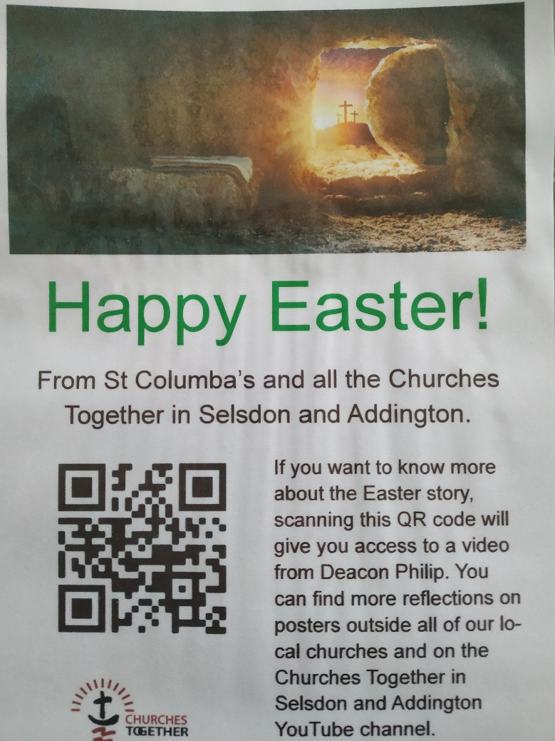

**WHAT’S THAT POSTER?**

Watch out for this poster in the window at St Columba’s.

You will also see it at six other places locally – the places of worship which together comprise Churches Together in Selsdon & Addington (CTSA), of which St Columba’s is an active member.

If you have a smartphone, you can scan the QR code (that’s the panel on the left with the black and white shapes).

Doing so will produce a short video film on your phone (no more than five minutes) with a message about an aspect of Easter.

In the case of St Columba’s that video features Deacon Philip talking about the Resurrection.

Why not make a little Holy Week pilgrimage of it all, visiting all seven churches as a mark of respect for Easter?

***GOOD FRIDAY UNITED SERVICE***

**All seven churches in CTSA have cooperated to produce an online united service for Good Friday morning.**

**It starts at 10am and you can access it via this link:**

[(416) CTSA Churches Together Selsdon and Addington - YouTube](https://www.youtube.com/channel/UCJGzFpcVZiwlN872pwbdl4A)