**St Columba’s Church, Selsdon**

37 Queenhill Road, Selsdon, South Croydon, CR2 8DW

Parish telephone number: 020 8657 3747

Parish Priest: Father Roy Tablizo

E: [selsdon@rcaos.org.uk](mailto:selsdon@rcaos.org.uk)

Deacon: Rev. Philip Pond E: [philippond@rcaos.org.uk](mailto:philippond@rcaos.org.uk)

T: 07764 845 890

Parish website: [www.stcolumbaschurchselsdon.uk](http://www.stcolumbaschurchselsdon.uk)

**4 APRIL 2021**

**EASTER SUNDAY (YEAR B)**

**THIS SUNDAY’S MASS READINGS**

**Entrance Antiphon:** I have risen, and I am with you still, alleluia. You have laid your hand upon me, alleluia Too wonderful for me, this knowledge, alleluia alleluia.

**A reading from the Acts of the Apostles: 10:34. 37-43**

**Responsorial Psalm PS 117:1-2. 16-17. 22-23. Rv.24:** This day was made by the Lord; we rejoice and are glad.

**2nd Reading: A reading from the letter of St Paul to the Colossians: 3:1-4**

**Gospel Acclamation:** Alleluia, Alleluia! Christ, our passover, has been sacrificed; let us celebrate the feast then, in the Lord. Alleluia!

**Gospel: John 20:1-9**

**Communion Antiphon:** Christ our Passover has been sacrificed, alleluia; therefore let us keep the feast with the unleavened bread of purity and truth, alleluia, alleluia.

**NOW WE HAVE THE BENCHES BACK**

Please make sure to leave plenty of space between you in the bench. There should be no more than three people – unless you are a family or in a bubble – ideally one person at each end, one in the middle.

Before you leave at the end of Mass lower the kneeler. If you were given a marker paper when arriving, leave it on the seat so that it’s obvious which part of the bench needs cleaning.

Do please be prepared to lend a hand helping the stewards clean the benches after Mass.

Don’t forget that the one-way system is still in force: come into the church via the Sacred Heart chapel/confessional and leave via the main door at the back.

*How you can recognise when the Lord is alive in your heart*

A reflection for Easter by Fr Roy

The Lord is Risen. That is good reason to celebrate.

The resurrection of Jesus Christ is the greatest good news that mankind has ever heard in the history of the world.

It will continue to resound as the same good news till the end of time.

Think about that…

We all often wonder about the mystery of our earthly existence.

The truth reveals to us that a creative force behind the order of this world is our God.

The same true God is responsible for orchestrating his redemptive scheme through the passion, death and resurrection of his son.

Jesus reveals to us the kingdom of God through his death on the cross.

Our own death and the end of our life is something that we should not be afraid of because Jesus has shown us that a much better life awaits us.

All we have to do is cooperate with the grace of God.

The present pandemic has shown us that life is fragile. The world is temporal. Any happiness it offers is only short-lived.

So we need to anchor our hope to something that is firm and permanent. That is our faith in Jesus.

In his Lenten message Pope Francis tells us “that our faith should lead us to the renewal of our prayer life.”

Building up a healthy prayer life will certainly lead us to a deeper faith in Jesus Christ. That is why we need to nurture it.

At the beginning of Lent, we all were urged to do just that. Now, as Lent ends, we are encouraged to carry on building a firm prayer life because this is the only way to mature in our relationship with God.

Pope Francis reminds us of the need to base our hope on God not on something flimsy or transient.

One benefit of the pandemic is the way it has brought home to all of us how transitory and deceptive are the world’s values compared to the lasting values of heaven.

But living God’s values requires discipline, for example fasting.

We have done well if we managed to curb our appetites during Lent. Now Lent is over God wants us to continue living those heavenly values and with greater intensity.

The level of discipline we have achieved needs to be amplified by a solid determination on our part to pursue God’s kingdom. In other words, continue Lenten fasting so as to sustain the momentum.

In his Lenten message Pope Francis pairs charity with almsgiving. This, together with the fruits of prayer and Lenten discipline, will lead us to be more mindful of the needs of the poor.

That is important because a genuine and close relationship with God should always be translated into charitable acts.

Likewise a deeper faith in Jesus will lead us into a deeper and more intense prayer life. Remember, our hope should not be based on the false securities of the world.

We need to discipline our appetite for selfish gratification and we can do that by fasting.

Learn to say no to anything that promotes selfish desires.

Finally, you will recognise that your charity is active if it brings a smile to the face of the needy. Do that – and you can be confident that the Risen Lord is alive in your heart.

***DON’T FORGET WHEN COMING TO ST COLUMBA’S…***

We know we must take precautions when coming to Mass. They are set by the Government – and the local council is checking that we comply. So make sure to:

* Remember to bring and wear a face mask covering the nose as well as the mouth
* Enter the church via the side door leading into the Sacred Heart chapel/confessional, observe the one-way system and leave via the centre back door.
* Meet Track-and-Trace requirements by providing a written note – and this applies every time you come to church – of your name and contact details (phone number or email or postal address) plus the date and, if relevant, Mass time. To save queuing and filling out a form, send an email to selsdon@rcaos.org.uk
* Use hand sanitizer, provided, both when entering and leaving the church.
* Unless they are in your family or bubble, leave plenty of space between yourself and anyone else in your bench – there should be no more than three people in a bench.
* Leave where they are the chairs which have replaced some of our benches and are at 1m intervals to ensure the necessary social distancing.
* Bring your own Mass or prayer book – there are no shared items:. That applies to readers as well.
* Keep silent when receiving Holy Communion.
* Leave the church straight after Holy Communion and don’t congregate outside to socialise.

|  |  |
| --- | --- |
| **LITURGICAL CALENDAR OF THE WEEK** | |
| Sat 3rd | Holy Saturday |
| Sun 4th | Easter Sunday |
| Mon 5th | Easter Monday |
| Tues 6th | Easter Tuesday |
| Wed 7th | Easter Wednesday |
| Thurs 8th | Easter Thursday |
| Fri 9th | Easter Friday |
| Sat 10th | Easter Saturday |
| Sun 11th | 2nd Sunday of Easter |

**REMEMBER THE SICK AND NEEDY**

Please pray for all those in need at this time including: Kevin Staunton, Alice Barclay, Thelma Benn, Julie Ballesteros, Cora Litchfield, Sean Walsh, Judy Freegard, Imogen Fernando, Joan Charman, Joan Cunningham, Solveya La Marina, Chris Jones, Maria Reece, Margaret Bolton, Eddie Aldridge, Ellis Warburton, Mary Marks, Jean-Claude Anthony, Ellen Everett, Maureen Coffey, James Guckian, Elizabeth Sensano, Stephen Beck and sick residents at the four residential homes usually, in better times, visited by the parish St Vincent de Paul group.

|  |  |  |
| --- | --- | --- |
| **MASS INTENTIONS FOR THE WEEK** | | |
| Sat 3rd | 6.30pm | Pro Populo |
| Sun 4th | 8.00am | Loretta Sean, Deni & Family, wellbeing |
| Sun 4th | 10.00am | Elizabeth Harris, RIP |
| Mon 5th | 10.00am | Mr Saminathar, RIP |
| Tues 6th | 10am | Service of Word & Communion |
| Wed 7th | 10.00am | Intention of the Alvarez Family |
| Thurs 8th | 8.00pm | May Lalley |
| Fri 9th | 3.00pm | Harry Sweeney, RIP |
| Sat 10th | 6.30pm | Weronika Lawicka, RIP |
| Sun 11th | 8.00am | Family McDonagh, Ann Matton |
| Sun 11th h | 10.00am | Pro Populo |
| Sun 11th | 6.30pm | Mary Charman, RIP |

**THAT PARISH COUNCIL MEETING: WHAT HAPPENED…**

For the first time after a gap of more than a year, because of Covid, St Columba’s parish council met last week – online, courtesy Zoom.

Some 21 people logged on to discuss and consider the best way forward for our parish after the disruption caused by the pandemic.

The primary focus was how to rebuild St Columba’s as a family once the main lockdown restrictions have been relaxed by the Government.

Various initiatives were suggested and discussed and there was agreement among parishioners about the way forward.

However, it was also agreed that until restrictions are relaxed as set out in the Government’s roadmap to recovery, major changes would be unwise as well as possibly being against the regulations.

However, we are as of now planning and preparing for the end of lockdown which will probably be on June 21.

Nonetheless there will be changes and improvements before then.

For example, the benches have already been returned to the church, albeit with limits on the number of people who can use them.

That will usually be a maximum of three, one at each end and one in the middle unless it’s a family or members of a bubble.

With these changes, up to 100 people can now be seated for Mass.

In order to help the stewards when cleaning benches after each service, parishioners are asked to leave the kneelers down so that it is obvious which have been used.

Where the kneeler is fixed, the people using that bench are asked themselves to take responsibility for cleaning the handrail as well as the seat itself. (There are cleaner sprays and hand towels both at the entrance to and exit from the church – help yourself.)

Hopefully starting soon there will be music and singing – though not by the congregation – at 10am Sunday Mass, a mixture of solos by invited guest singers and pre-recorded hymns.

Those wishing to receive the Sacrament of Reconciliation can do so now – if you wish to go to Confession, contact Fr Roy for an appointment.

Other initiatives planned for the end of lockdown (dates to be confirmed) include:

* A welcome-back newsletter with an invitation to return from our parish priest, Fr Roy, posted through all parishioners’ letterboxes the week before the church fully reopens.
* Café St Columba to reopen for morning coffee (and home-made cakes) and light lunches on one Wednesday a month.
* Coffee mornings after Sunday 10am Mass.
* Preparation for and celebration of First Communions - the date to be announced (all interested parents should contact Fr Roy without delay).
* The Sacrament of Confirmation – youngsters aged 13 or 14 wishing to be confirmed are invited to get in touch with Fr Roy now about a course of preparation.
* Uniformed groups – Rainbows and Brownies have continued to meet during lockdown, having fun’n’games on Zoom. The Guides are planning a programme of events. (More details from Yvonne Barnard overleaf.)

Other initiatives as well as a choice of social events are being planned and will be announced in due course. Watch this space…

The final message from the parish council meeting was simple. As we look forward to the end of lockdown, in order to keep everyone safe and well we must all continue to observe all the precautions that have been in force over past months. You can see those in detail overleaf.

**WANT TO GO TO CONFESSION?**

Well you can – and at the same time be confident that you are safe from Covid.

Simply give Fr Roy a ring and make an appointment.

**RAINBOWS, BROWNIES & GUIDES**

During the pandemic, Rainbows and Brownies have been using Zoom to meet online. The girls have enjoyed planned activities in their own homes and are hoping to meet outdoors and face to face after Easter.

The numbers have maintained and even grown, which is incredible at this moment in time. It shows that organisations like this are where parents are looking to help their children have access to activities and see their friends, be it currently only online.

The Guides have taken a break from meeting during the lockdown, but as it eases they will start to come together again, outdoors, from the March 29. We are following the Girlguiding and the Government guidelines and have been advised that meetings indoors can begin again after the summer break in September.

If your daughter would like to learn more about the exciting and interesting activities that take place in Rainbows, Brownies or Guides, then please feel free to contact Yvonne Barnard (07765 104307). She would be delighted to share her many years of experience and advise how your daughter can be registered to join the world of Girlguiding.

***IF YOU TEST POSITIVE FOR COVID…***

Should that happen and you have been to Mass at St Columba’s in the preceding week, let Fr Roy or Deacon Philip know.

For track’n’trace purposes, they may then need to contact anyone else who was at the same Mass.



***SHOP ONLINE AND HELP ST C’S TOO***

Thinking of buying something online? Anything? A new washing machine or any other white goods?

Or perhaps you need a new vacuum cleaner or intend ordering a book or dvd or, in fact, other items.

If you do it online you can help St Columba’s finances, depleted by the lockdown, at the same time and at no cost to yourself.

More and more parishioners are signing up for this scheme. It means that you can turn your everyday online shopping into free donations to our parish.

It’s simple. It’s straightforward. And it will cost you nothing.

All you have to do is to logon to the following website [www.easyfundraising.org.uk](http://www.easyfundraising.org.uk), register (which is quick and easy) and then go shopping online at whichever retailer you choose. Each time you buy something – anything – a small donation is made to St Columba’s.

|  |  |  |
| --- | --- | --- |
| There are more than 4,000 retailers to choose from including lots of big names such as Argos, John Lewis, Amazon, M&S and Sainsbury’s.  Have a look at this link to find out more: [https://www.easyfundraising.org.uk/causes/stcolumbasldn/?invite=ZTUSO0%26referral-campaign=c2s%26utm_campaign=admin-trigger%26utm_content=nst](http://t.e.easyfundraising.org.uk/r/?id=h2ef6bab4,257a256b,25302fff&utm_source=adobecampaign&utm_medium=email&utm_campaign=referral-2018&utm_content=trigger-supp-referee-raised-2018&origin=RTNS2&p1=stcolumbasldn&p2=ZTUSO0)   * ***GOOD NEWS So far 23 parishioners have signed up for easyfundraising, raising £165 for St Columba’s (at no cost to themselves). Well done all, and many thanks.***   **WHAT DO YOU THINK OF IT SO FAR…?**  **Our newsletter, that is.**  **Your comments, thoughts, suggestions, ideas and contributions would be most welcome.**  **They will also enable us to know whether this newsletter is considered helpful and useful – or not. Email Deacon Philip – the deadline for each weekend’s newsletter is the Wednesday before.** |  |  |

**FAITH COMPANION: TASTE AND SEE**

The *Faith Companion* is an online magazine likely to be of interest to parishioners and recommended by our own Abp John.

Visit its website and you will also find details of Christian Gifts online including the *Faith Companion* candle, rosaries, journals and a skin care range made by Benedictine monks.

A free copy of the magazine is obtainable to “taste and see” by visiting the website at <http://www.thefaithcompanion.co.uk>. Please do consider supporting their work for the Church.

**COLLECT YOUR GIFT AID ENVELOPES**

**All members of the Gift Aid scheme are invited this weekend to collect their boxes of envelopes for the coming year.**

**The boxes, with your names on, can be collected at the entrance to the sacristy in the Sacred Heart chapel after all Masses.**

**THINK YOU HAVE A VOCATION?**

The Beda College in Rome is running a discernment weekend for men between the ages of 30 and 55 from September 3-5. It takes place at St Beuno’s Spirituality Centre in North Wales.

The weekend is a first step for those who may be exploring the possibility of priestly vocation in later life.

Information and registration forms are at: <https://www.pathwaystogod.org/courses-events-retreats/discernment-weekend-older-men-1>

**HOW DID COVID AFFECT YOU?**

Our diocesanAgency for Evangelisation and Catechesis has partnered with other dioceses to produce and promote a survey which aims to find out about the experiences of Catholics over the period of the Coronavirus pandemic.

This research will help us to understand what has been happening during this time when churches have been closed and/or only opened for limited periods and Catholics have had to practice their faith ‘at a distance’. To complete the survey, select our Archdiocese from the drop-down menu so that we can hear about what God has been doing and what He wants to say to us about the future of the Church in this part of England and Wales.

This important survey should take about 10 minutes to complete and the deadline for submissions for Southwark is July 4. Click on this link:

<https://forms.rcaos.org.uk/covid-19-survey-form/>

**VICTIMS & SURVIVORS OF ABUSE**

**Make a note in your diary. There will be a day of prayer for victims and survivors of abuse on May 4. More details to follow nearer the time.**

**EASTER SERVICES WITH ABP JOHN**

Various services celebrated by our Archbishop John Wilson are going to be livestreamed from the Cathedral:

Holy Saturday 3 April: 20:30 Paschal Vigil

Easter Sunday 4 April: 10:00 Family Mass

**For more details visit the Southwark diocesan website:** <http://www.rcsouthwark.co.uk/>

**KEEPING ST COLUMBA’S OPEN DURING THE PANDEMIC**

**We have a number of parishioners who have been doing an invaluable job during the pandemic to ensure that St Columba’s can stay open for Mass.**

**They are the stewards who check people into the church before Mass starts, ensure they provide a completed track’n’trace form and make sure everyone uses hand sanitizer. After Mass they clean the seating which has been used and sanitize door handles and the like.**

**These volunteers are essential if we are to keep St Columba’s open during the pandemic.**

**But there are not enough of them: we need more, especially now that the benches are back in use and numbers attending Mass hopefully will start to increase.**

**If you are willing to help - and do give it serious consideration - contact Fr Roy or Deacon Philip.**



**DOUBLE YOUR MONEY BY HELPING THE HOMELESS**

The Passage’s mission and work are developing to cope with more people becoming homeless.

Currently it is raising funds through the Big Give – which runs until Wednesday (March 31) – to support No Night Out, a new initiative to take newly homeless people off the street straight away.

Visit the website: [www.passage.org.uk](http://www.passage.org.uk) for more details.

Double your donation, double your impact: this is a matched giving scheme for online donations.

If someone (it can be a company, individual or trust) gave £10, the scheme would bring the gift up to £20. With gift aid that goes up to £22.50 for an individual.

For someone on higher rate tax it could cost the donor less than £10.

For more information ring 020 75921886 or email [andrew.h@passage.org.uk](mailto:andrew.h@passage.org.uk)

You can donate at <https://tinyurl.com/NoNightOut>

**OUR EASTER SERVICE TIMES**

Holy Saturday: 8.30pm The Easter Vigil

Easter Sunday: 8am Mass

10am Mass

***Note that there will be no singing and no Mass Easter Sunday evening.***

**KNOW OF ANYONE IN NEED?**

Are you aware of any parishioners living alone or in need?

If so, as well as phoning them yourself occasionally to see if they need anything, let Fr Roy or Deacon Philip know of their whereabouts.

That way, we can work together to support and help them at this difficult time.

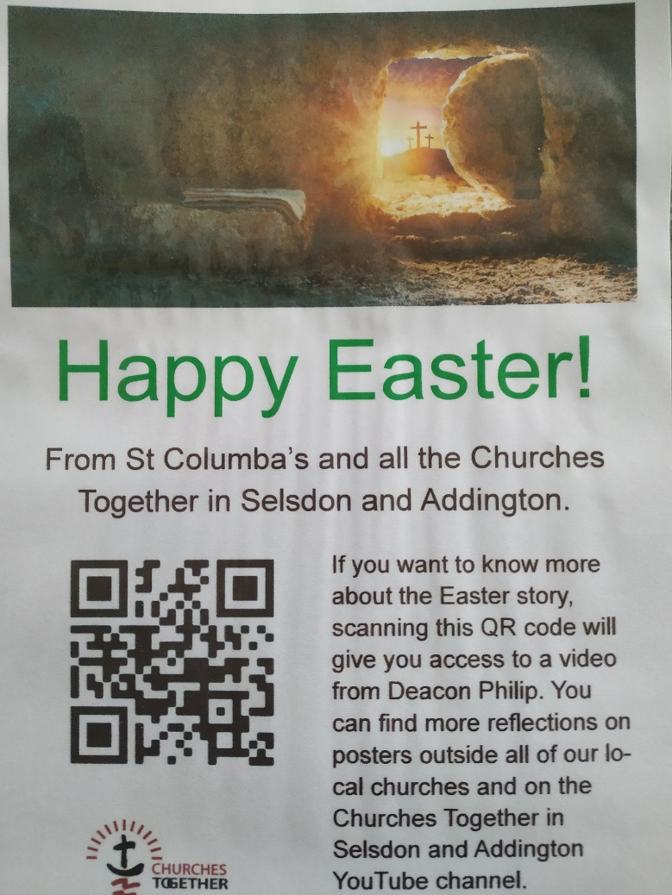

**WHAT’S THAT POSTER?**

Watch out for this poster in the window at St Columba’s (by the entrance).

You will also see it at six other places locally – the places of worship which together comprise Churches Together in Selsdon & Addington (CTSA), of which St Columba’s is an active member.

If you have a smartphone, you can scan the QR code (that’s the panel on the left with the black and white shapes).

Doing so will produce a short video film on your phone (no more than five minutes) with a message about an aspect of Easter.

In the case of St Columba’s that video features Deacon Philip talking about the Resurrection.

Why not make a little Holy Week pilgrimage of it all, visiting all seven churches as a mark of respect for Easter?

**ST JOSEPH’S 150TH ANNIVERSARY**

In preparation for the 150th anniversary of the opening of St Joseph’s School, Upper Norwood, former pupils, parents, staff, governors and friends are invited to submit recollections, photos and memorabilia.

They will be displayed in anniversary publications and at events. Please include a description of any items sent, name people in photos and add a date or occasion when the photograph might have been taken.

During the celebratory year, beginning in September, there will be many opportunities to visit St Joseph’s and to meet with other Alumni to mark this special milestone. Please help spread the news to all those associated with St Joseph’s.

To share memories of your days at St Joseph’s, or to receive more information as the plans for the anniversary year unfold, please email your contact details to: [alumni@st-josephs-jun.croydon.sch.uk](mailto:alumni@st-josephs-jun.croydon.sch.uk)

For more details visit the school’s website: <https://www.stjosephsfederation.co.uk/>

**GOING INTO HOSPITAL? TELL US**

If you or a member of your family go into hospital, ask the Ward Sister or Staff Nurse to notify the hospital’s Roman Catholic hospital chaplain direct.

That will make it much more likely that you have the opportunity of receiving Holy Communion (or any other sacraments) while in hospital. And don’t forget to let Fr Roy or Deacon Philip know beforehand of your admission into hospital. We can then keep you in our prayers.

**‘THANK YOU’ FROM FR ROY**

**Fr Roy would like to thank all parishioners for their Easter offerings, which are very much appreciated as a personal gift to the parish priest.**