**St Columba’s Church, Selsdon**

37 Queenhill Road, Selsdon, South Croydon, CR2 8DW

Parish telephone number: 020 8657 3747

Parish Priest: Father Roy Tablizo E: [selsdon@rcaos.org.uk](mailto:selsdon@rcaos.org.uk)

Deacon: Rev. Philip Pond E: [philippond@rcaos.org.uk](mailto:philippond@rcaos.org.uk)

T: 07764 845 890

Parish website: [www.stcolumbaschurchselsdon.uk](http://www.stcolumbaschurchselsdon.uk)

**AUGUST 30, 2020**

**22nd SUNDAY IN ORDINARY TIME (YEAR A)**

**THIS SUNDAY’S MASS READINGS**

**Entrance Antiphon:** Have mercy on me, O Lord, for I cry to you all the day long. O Lord, you are good and forgiving, full ofmercy to all who call to you.

**1st Reading: from the prophet Jeremiah 20:7-9**

**Responsorial Psalm Ps 62:2-6,8-9. R. v.2** For you my soul is thirsting, O Lord my God.

**2nd Reading: from the letter of St Paul to the Romans 12:1-2**

**Gospel Acclamation:** Alleluia, alleluia! May the Father of our Lord Jesus Christ enlighten the eyes of our mind, so that we can see what hope his call holds for us. Alleluia!

**Gospel: Matthew 16:21-27**

**Communion Antiphon:** How great is the goodness, Lord, that you keep for those who fear you.

**SERVICES AT ST C’S THIS COMING WEEK**

Have you come back to church yet?

The obligation to attend Sunday Mass is still suspended. But here’s a reminder: if you are able to come, all are welcome to 10am Mass at St Columba’s every day of the week except Saturday.

In addition, as well as 8am and 6.30pm Mass every Sunday, there is a vigil Mass at 6.30pm on Saturdays. If you are not still shielding, do feel free to come and join us.

Don’t forget either that Adoration in front of the exposed Blessed Sacrament has resumed every Tuesday.

It is limited in time to one hour from 10.30-11.30am. If you are staying on for Holy Hour after Mass simply return to your seat after Holy Communion.

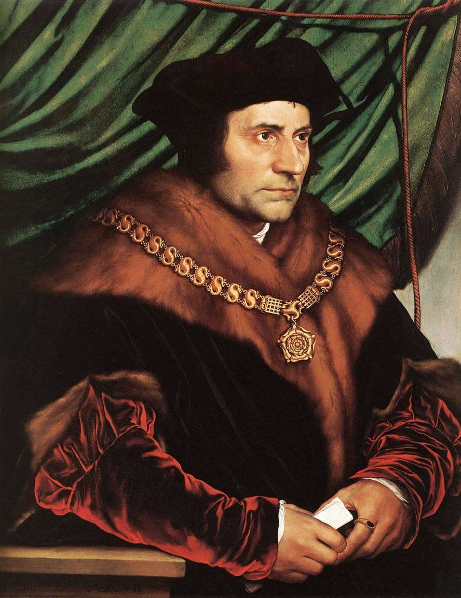

***THE LESSON TO BE LEARNED FROM ST THOMAS MORE***

**A REFLECTION ON THE GOSPEL FOR THE 22nd SUNDAY BY FR ROY**

Today’s Gospel reminds me of the film about St Thomas More, “A Man for All Seasons.”

The opening scene shows Richard Rich, having just finished his studies in Cambridge, looking for a job. Meanwhile St Thomas More has, at this point, reached the peak of his career as Chancellor of the Exchequer.

I love this opening scene. Linked to the end of the film, it provides a powerful contrast between More, who lived up to Gospel values, and Rich, who only reached the peak of his career at the expense of his own soul.

King Henry VIII did everything in his power to persuade Thomas More to support the annulment of his marriage to Queen Catherine of Aragon – and failed.

The king’s objective was to be able to marry Anne Boleyn legally and produce an heir to the throne. What stands out amidst all this drama is More’s following his conscience, no matter what the consequences.

He refuses to compromise the well-being of his soul despite the pressure coming from all sectors of society.

His spiritual relationship with God is clearly More’s most precious possession.

He was willing to give up everything - his noble career, his family and ultimately his life – to protect the integrity of his relationship with God.

Thomas More’s loyalty to Gospel values is uncompromising. It was for this reason he paid the ultimate price, sacrificing his life for the Kingdom of God.

The person who caught my attention in the film was Richard Rich. He started as a lowly university graduate looking for a job then, using his wits, quietly climbed the ladder of success.

Eventually, in exchange for his perjury as a witness, he is rewarded with high office.

For this, St Thomas More had a lovely and powerful comment: “It profits a man nothing to give his soul for the whole world…but for Wales!”

Towards the end of the film, it is mentioned that after the trial Rich became more prominent in the kingdom and that he died in his sleep.

This is really sad because for all his success in life, Rich forfeited his salvation by pursuing the wealth of this world.

This is exactly the point made by Jesus in today’s Gospel.

***‘…it reminds us to set our sights on heavenly values not worldly values…’***

Our souls are our only genuine wealth and we can and should never exchange them for the wealth of this world.

It is an appropriate point to bear in mind during this Covid-19 pandemic.

It reminds us to set our sights on heavenly values not worldly values.

To conclude, St Thomas More teaches us a powerful lesson: “death comes for us all, even for kings.”

In other words, our life span is limited and we put our spiritual selves, our souls, dangerously at risk by entrusting ourselves to the values of the world.

It was his thoughts and his heart that sent More to prison. It was his conscience and loyalty to the teachings of the Church that led him to death.

But he was prepared to face death because his loyalty to the Gospel was more important than anything else.

The lesson is clear for all of us.

It takes courage to overcome the temptations of this world.

Yet we can never compromise because our souls must be the top priority in our lives.

**ALL MASSES FROM ST COLUMBA’S ONLINE**

Follow Fr Roy celebrating Mass live on YouTube – <https://www.youtube.com/channel/UCYVyZ2Xpfs0NiuU3bxAjsCQ/live>

10am Mass is also live streamed daily (except Saturday) on Zoom:

<https://us04web.zoom.us/j/73986660636?pwd=UkJMZHQ0S1ZYUDdOR21MVkpYZElBdz09>

***COVID 10 COMMANDMENTS FOR COMING TO CHURCH…***

We are gradually getting back to normal after the months of lockdown. Daily Mass and weekly Adoration have both resumed at St Columba’s.

But this is a ‘new normal’ with changes that we would have thought unthinkable last year.

So don’t forget, whether coming to Mass or to Tuesday Adoration, that we must all comply with the following ‘Ten Commandments’:

1. Remember to bring and wear a face mask.
2. Enter the church via the side door leading into the Sacred Heart chapel/confessional, observe the one-way system and leave via the centre back door.
3. Provide a written note – and this applies every time you come to church – of your name and contact details (phone number or email or postal address) plus the date and, if relevant, Mass time. To save queuing, why not send an email to selsdon@rcaos.org.uk?
4. Use hand sanitizer, provided, both when entering and leaving the church.
5. Do not move the chairs which have replaced our benches and are at 1m intervals to ensure the necessary social distancing.
6. Don’t expect to find Mass or prayer books or any other shared items: bring your own.
7. Remember that singing is not allowed.
8. Don’t forget that Holy Communion is silent.
9. Before leaving, turn your chair back to front so that the stewards know which ones to clean afterwards.
10. Unless staying for Adoration, on Tuesdays, leave the church straight after Holy Communion.

* ***Please note: the toilets at church cannot be used.***

**REMEMBER THE SICK AND NEEDY**

Please pray for: Elena Sandland, Imogen Fernando, Vera De Souza, Ian Messenger, Baby Tommy, Joan Charman, Roger Fenton, Deacon John Letley, Joan Cunningham, John Davis, Noreen Lawlor, Solveya La Marina, Chris Jones, Maria Reece, Margaret Bolton, Eddie Aldridge, Ellis Warburton, Mary Marks, Margaret Edwards, Jean-Claude Anthony, Ellen Everett, Maureen Coffey, Albert Khayyat, Grant Russell, James Patrick Guckian, Elizabeth Sensano and sick residents at the four residential homes usually, in better times, visited by the parish SVP group.

**LITURGICAL CALENDAR FOR THE WEEK**

Sat 29th: The Passion of St John the Baptist

Sun 30th: 22nd Sunday in ordinary time year A

Mon 31st: Feria or St Aidan & the saints of Lindisfarne

Tues 1st: Feria

Wed 2nd: Feria

Thurs 3rd: St Gregory the Great

Fri 4th: Feria or St Cuthbert

Sat 5th: Feria or Our Lady

Sun 6th: 23rd Sunday in ordinary time year A

**ARRANGING TO HAVE A MASS SAID**

If you wish to have a Mass offered for a special intention, you can do so. Email the details to Fr Roy. Or write them out and post or deliver them to the presbytery. The information needed is the name of the person for whom the Mass is to be offered and whether they are deceased and if there is a specific anniversary or if it is some other special intention; also the date on or near which you would like the Mass to be celebrated; plus your own name and phone number/email address.

* It is customary to make an offering to the priest when asking for a Mass to be celebrated.

**GOING UP! 70 NOW ALLOWED IN CHURCH**

Originally the number was lower but as a result of some more rearranging last week we can now accommodate up to 70 people in church.

***If there are already that number inside when you arrive, the stewards will advise that you cannot come into the church.***

So far that situation has not arisen – 45 is the largest number we have had at St Columba’s and that was for a 10am Sunday Mass. So plenty of room.

A reminder: we must ensure social distancing in St Columba’s. That’s why chairs have replaced the benches. Chairs also make it easier to keep seating clean and clear of Covid-19. They are cleaned after every Mass.

***HOW YOU CAN HELP ST COLUMBA’S WHILE DOING YOUR SHOPPING ONLINE***

Thinking of buying something online? Anything? A new washing machine or fridge or freezer or tumble dryer or any other white goods?

Or perhaps you need a new vacuum cleaner or intend ordering a book or dvd or, in fact, any other items you need?

If you do it online you can help St Columba’s finances, depleted by the lockdown, at the same time and at no cost to yourself. More and more parishioners are signing up for this scheme.

It means that you can turn your everyday online shopping – not just of white goods but anything – into free donations to our parish.

It’s simple. It’s straightforward. And it will cost you nothing. All you have to do is visit the

[www.easyfundraising.org.uk](http://www.easyfundraising.org.uk) website, register (which is quick and easy) and then go shopping online at whichever retailer you choose.

Each time you buy something a small donation is made to St Columba’s.

There are more than 4,000 retailers to choose from including lots of big names such as Argos, John Lewis, Amazon, M&S and Sainsbury’s. Have a look at this link to find out more:

|  |  |  |
| --- | --- | --- |
| [https://www.easyfundraising.org.uk/causes/stcolumbasldn/?invite=ZTUSO0%26referral-campaign=c2s%26utm_campaign=admin-trigger%26utm_content=nst](http://t.e.easyfundraising.org.uk/r/?id=h2ef6bab4,257a256b,25302fff&utm_source=adobecampaign&utm_medium=email&utm_campaign=referral-2018&utm_content=trigger-supp-referee-raised-2018&origin=RTNS2&p1=stcolumbasldn&p2=ZTUSO0)   * ***Stop Press: St Columba’s has just received new donations of £46.90 as a result of parishioners buying items via*** [***www.easyfundraising.org.uk***](http://www.easyfundraising.org.uk)***. Thank you and well done.***   **PRAYER INTENTIONS FOR SEPTEMBER**  During September we are asked to pray for the following intentions: students and teachers; the spread of the Gospel; the harvest, the fruits of human work and the reverent use of creation; justice and peace; all victims of war; young people; and prisoners and their families. Please remember them in your prayers.  **JUST PUBLISHED: A TALE OF ENDURANCE**  *Ten Long Days* is the title of a new book which tells the extraordinary story of Joan de Souza’s escape to India from the Japanese after they invaded Burma during the Second World War. Joan, a valued member of our parish, was 12 at the time. Available from Amazon and all good bookshops. Highly recommended.  **OFFERTORY COLLECTION**  Thank you for your kind offering at Mass.  To correct the item in last weekend’s newsletter, the £810.74 mentioned (of which £395 was covered by Gift Aid and £415.74 was not) was the amount raised at Mass over the weekends of July 25/26 and August 1/2 combined.  If you are a taxpayer and not already signed up for Gift Aid (which, at no cost to you, enables St Columba’s to reclaim from the Government tax you have already paid) contact Fr Roy or Deacon Philip for details of how to join the scheme.  **PRAY FOR THE DECEASED** |  |  |

Please pray for the repose of the soul of Nina Wade, a 90-plus-year-old Polish parishioner who died this week. Funeral arrangements have yet to be announced. May she rest in peace.

**MASS INTENTIONS FOR THE WEEK**

Sat 29th: 6.30pm Holy Souls

Sun 30th: 8am Pro Populo

SUN 30th 10am Joe D’Souza RIP

Sun 30th: 6.30pm Holy Souls

Mon 31st: 10am Wedding Anniversary William & Cielo

Tues 1st: 10am Vera De Souza

Wed 2nd: 10am Caguioa family (thanksgiving)

Thurs 3rd: 10am Holy Souls

Fri 4th: 10am Holy Souls

Sat 5th: 6.30pm Holy Souls

Sun 6th: 8am Holy Souls

SUN 6th: 10am Pro Populo

Sun 6th: 6.30pm Holy Souls

**HOW ABOUT MARRIAGE ENCOUNTER..?**

For the past 50 years Worldwide Marriage Encounter has been offering marriage enrichment retreats all around the world.

They are aimed at couples in average-to-good marriages who want to enrich their relationship and gain a deeper understanding of the Sacrament of Marriage.

The Marriage Encounter experience offers a unique experience to explore your relationship at a deeper, more intimate level, regardless of how long you have been together.

During the coronavirus pandemic, the residential retreats have had to be cancelled.

In their place, for couples who want to deepen their relationship, is a newly energised video conferenced retreat.

So why not give yourselves and your relationship a treat and sign up for the next online experience scheduled for September 26-27?

Find out more at wwme.org.uk or telephone 0845 260 2016

**MAKE YOUR OWN GIFT AID ENVELOPES**

We have not been able to distribute new Gift Aid envelopes because of the coronavirus. There is a way round that, however, to ensure that St Columba’s continues to benefit from Gift Aid. All you need to do is to put your offering in any blank envelope on which you then write ‘Gift Aid’ plus your name. Then place that envelope in the Offertory collection box/basket at church. Better still, set up a standing order.

**CATHEDRAL JOB VACANCIES**

There are two part-time admin vacancies at St George’s Cathedral, Southwark.  For more information please contact [triciagilbride@stgeorges.org.uk](mailto:triciagilbride@stgeorges.org.uk). Closing date for applications is 1st September.

**NOT RECEIVING HOLY COMMUNION?**

If you are not receiving Holy Communion at Mass, for whatever reason, please do come forward with the communicants and receive a blessing. Indicate in the usual way: by crossing your arms across your chest.

**FIRST HOLY COMMUNIONS**

There will be a team meeting on Tuesday to plan for our parish First Holy Communion day. Parents of children who began their preparation last October and should have received their First Holy Communion on June 27 this year will be contacted shortly with details and a date, hopefully in the autumn. Watch this space…

**THIS NEWSLETTER: HAVE YOUR SAY**

Items for publication should be emailed to [Deacon](mailto:kyrabarone@aol.com) Philip by Thursday evening at the latest.

**ON TUESDAY, REMEMBER CREATION**

Tuesday (the 1st) has been designated as the World Day of Prayer for the Care of Creation. Don’t forget…