Bishops’ Statement: Honouring Sunday
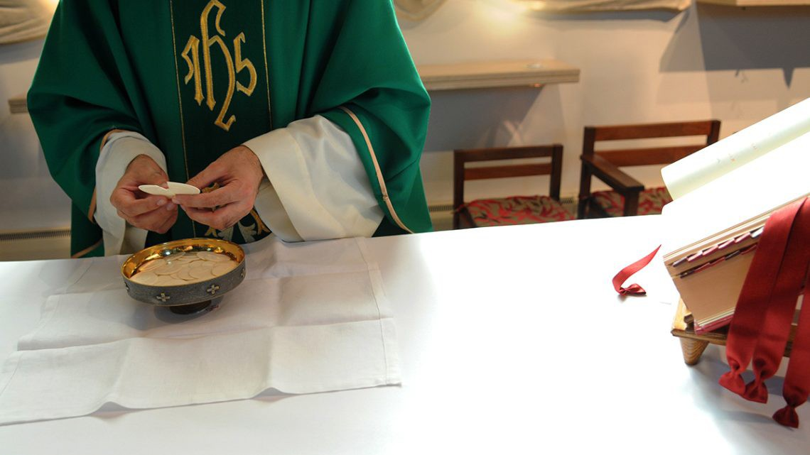
During the pandemic, public worship was suspended for a time and there have been restrictions on parish life. As a result, people have been exploring other ways to practice their faith including Spiritual Communion via live streaming.

As people begin returning to more regular patterns of parish life and following the first face to face meeting of the Catholic Bishops of England and Wales in Leeds, the bishops have issued the following statement about the importance of honouring Sunday:

Honouring Sunday

As the Synodal Pathway of listening and discerning unfolds, we the bishops of England and Wales, are paying particular attention to the hopes and fears, the joys, and anxieties of all who are sharing their thoughts and feelings with us.

Longing for our Lord

We are attentive to the experience of the last year or so, when we have lived our faith through the limitations of the pandemic. We have heard of the longing which some express as a “homesickness”. We want to be in the presence of the Blessed Sacrament. We yearn to celebrate the sacraments together, especially the Holy Sacrifice of the Mass. We desire to be nourished by our Lord in Holy Communion. The live streaming of the Mass and the remarkable response of our Catholic communities to those in need, have provided comfort, sustenance and resilience.

The Eucharist, source, and summit

The Eucharist is the source and summit of our spiritual and pastoral life. Many people have said to us that they have appreciated the noble simplicity of the Mass at this time, which has allowed the mystery and majesty of our Lord’s sacrificial love to shine through.

The central appeal of the Mass, its beauty, and its transcendence, raises our minds and hearts to God in an unambiguous and compelling manner. Our Lord Jesus invites us to receive anew the gift of Sunday as the preeminent day, the day of the Resurrection, when the Church gathers to celebrate the Eucharist. Here we stand together before our heavenly Father, offering our thanksgiving and prayer, through our Saviour in the Holy Spirit. Here we receive Christ in his Word. Here we are nourished by Christ in his precious Body and Blood. This is our primary joy, for which there is no substitute, and from which we draw our strength.

The Gift of the Sunday Eucharist

The Sunday Eucharist is a gift; as God’s holy people we are called to praise and thank God in the most sublime way possible. When the Church speaks of the Sunday obligation, it reminds us that attending Mass is a personal response to the selfless offering of Christ’s love.

At this time, we recognise that for some people there may be certain factors which hinder attendance at Sunday Mass. The pandemic is clearly not over. The risk of infection is still present. For some, there is legitimate fear in gathering together. As your bishops, we recognise that these prevailing circumstances suggest that not everyone is yet in the position to fulfil the absolute duty to attend freely Sunday Mass.

Responding to the Gift

We now encourage all Catholics to look again at the patterns which they have formed in recent months with regard to going to Mass on Sundays. This would include consideration and reflection about what we might do on Sundays, such as sports or shopping, or other leisure and social activities. This review, and the decisions which arise from it, fall to every Catholic and we trust this will be done with honesty, motivated by a real love for the Lord whom we encounter in the Mass.

The Sunday Mass is the very heartbeat of the Church and of our personal life of faith. We gather on the “first day of the week,” and devote ourselves to the apostles’ teaching and the fellowship, to the breaking of bread and the prayers (Acts 2:42). The Eucharist sustains us and spurs us on, renewing our gratitude and our hope. When we say “Amen” to Christ in receiving his Body and Blood, we express the love of God which is deep within us, and at the end of Mass, when we are sent forth, we express our love for our neighbour, especially those in need. These two dimensions reveal the full meaning of our faith. We are gathered together and sent out, we pray and are fed, we worship and we adore; these are intrinsic to our lives as those baptised into Christ.

Approved at the Plenary Assembly of Bishops in Leeds - Friday, November 19th, 2021

